Design Project: IR Emitter Mount and Steering Module
Preliminary Design
Eric Booen
OPTI 523
Introduction:
An infrared (IR) emitter produces a 2 mm collimated beam that will be used to as a boresight reference for a 1064 nm laser beam. A mount will be designed that initially aligns the IR light to the 1064 nm laser beam within 75 μrad. In addition, the IR beam must be maintain boresight with the 1064 nm laser beam over a large operating temperature range (-40 to 80C), a moderate vibration profile, and a 20 G shock. The module will be designed as a drop-in module that can be easily installed to an existing laser system. No maintenance can be allowed so locking features on any adjustment are required.

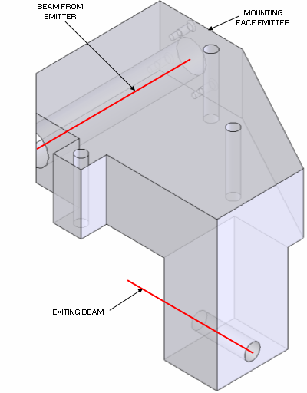

ICD:
The design of the laser system is such that the IR module must “drop-in” to features machined into the existing laser bench. As many of the laser components have already been designed, the volume allocated for the IR source is very small (See Appendix A).

In addition, the light source has already been designed. A simplified model of the emitter has been designed and the Steering Module will provide mounting features and clearance for the emitter (See Appendix B).

The laser bench interfaces have not been permanently defined and there may be some flexibility. For now assume a flat plate made from Aluminum 6061-T6. The volume requirement for this system will be one of the most challenging specifications to meet.

Optical Requirements:
- Wavelength – MWIR (3 – 8 μm)
- Beam Diameter – 2 mm
- Initial Alignment to 1064 nm Beam – 75 μrad
- Max Error in 1064 nm beam – 1.5 mrad
- 1064 nm beam size 8 mm
- IR beam shall be contained within the nominal location of the 8 mm 1064 nm beam (beam decenter specification)
- Boresight Stability (Temperature, Vibration, Shock) – 25 μrad

Environment:
- Operating Temperature -40 C to 80C
- Storage Temperature -57 to +85C
- Operational vibration in accordance with MIL 810F, Method 514.5, Category 13 and 14
- Module must survive 100 G shock load

Other:
- All material used must be low outgassing (>1% TML, >.1% CVCM)
- No maintainence will be allowed for life of system
- Life of system is 5 years – designed for 20,000 hours of operation

Preliminary Design:
The design of the IR Steering Module includes a monolithic aluminum bench that serves as the mounting surface for each optical component. Three fold mirrors will fold the beam from the IR emitter to the exit beam location defined in the ICD. The mirrors will be made from fused silica and coated with gold. The sizes of the mirrors have been selected as they fit the form factor for commercially off the shelf mirrors.
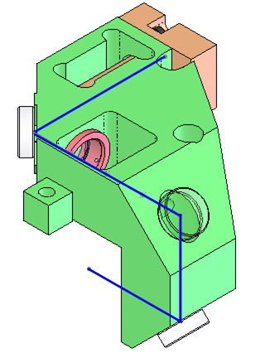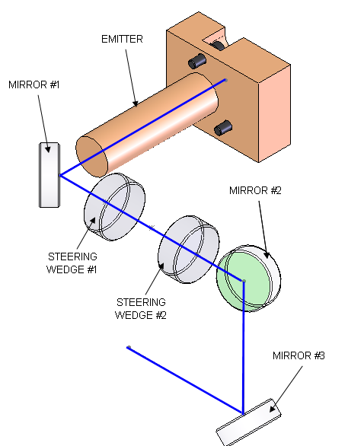

Figure 1: Preliminary design and optical layout

As there is a large temperature range, the mirrors will be mounted to lapped pads cut into the Steering Module bench (See Figure 1, Figure 2). This is a semi-kinematic mount that should be very stable over the large temperature range. The springs will be designed based on the criteria presented by Yoder.
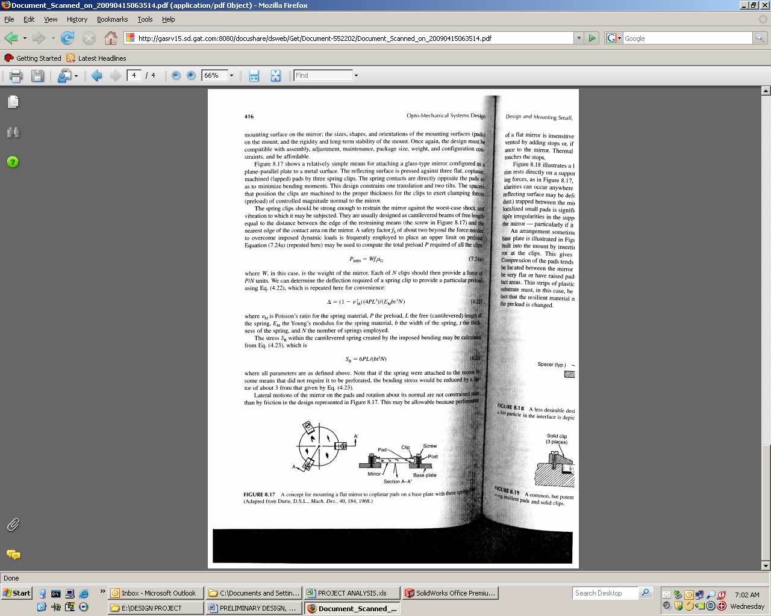

This simple mounting technique is the mounting technique that requires the least amount of space.

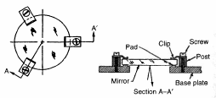

Figure 1: Semi-kinematic mirror mount design (Figure from Yoder)

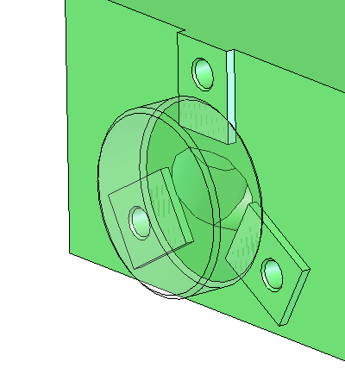
Figure 2: Actual mounting geometry for Steering Module – Post and Clips not shown for clarity

Adjustment of the IR beam will be made with one set of Risley prisms. The prisms material will need to be transmissive through the MWIR wavelength range and will need to have a low dispersion over the entire MWIR range. Some candidate materials include Calcium Fluoride, Magnesium Fluoride, Sapphire, and Zinc Selenide. The prisms will be bonded into rotation mounts made from Aluminum 6061-T6 with Mil-Bond. The hole in the Steering Module Bench will be sized in accordance with the outer diameter of the rotation mount.

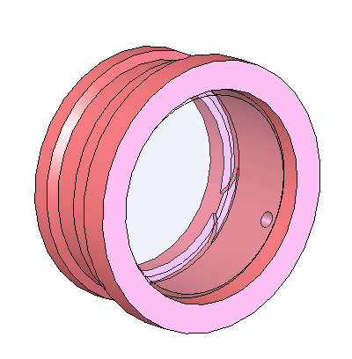

Figure 3: Prism will be bonded into the rotation mount
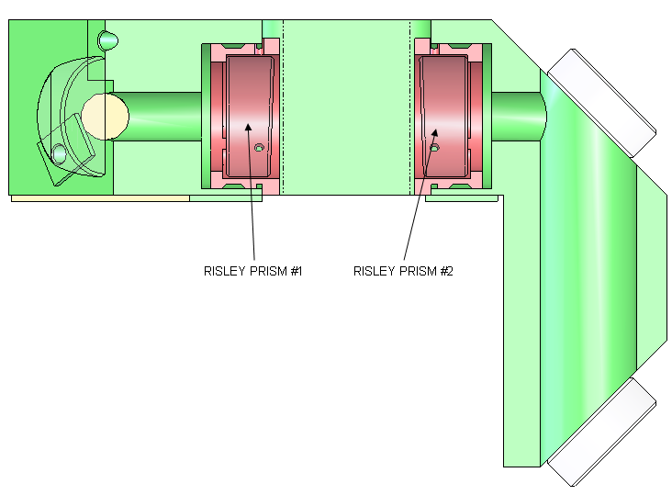
Figure 4: Cross section of Steering Module bench

The adjustment of the Steering Module will be made by rotating the Risley prisms with respect to one another. The prisms angle will be determined based on a tolerance analysis of the position and orientation of each component within the system. The sizing of the wedges will be made based on the following equation and Figure 5.
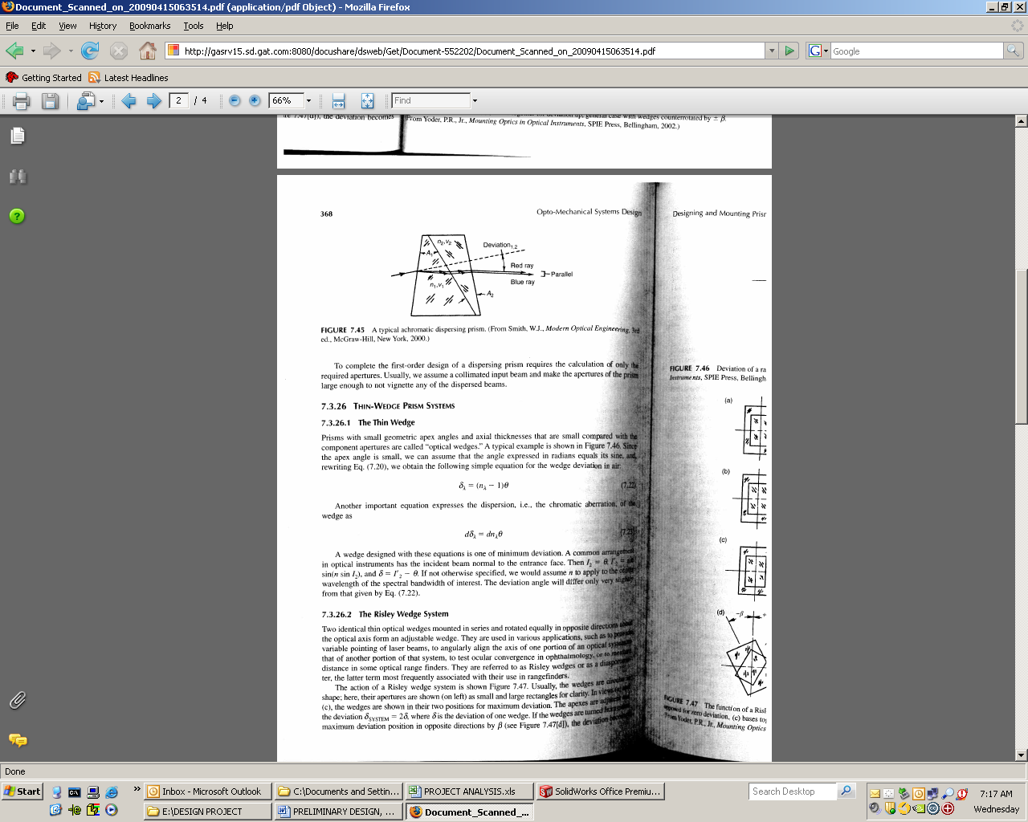

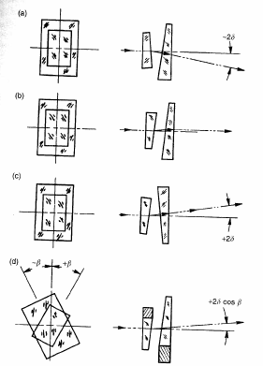
Figure 5: Risley prism schematic (from Yoder)

A small tool will be inserted into the radial holes on the outer diameter of the rotation mount. The tool will act as a lever to rotate the prism about the optical axis of the Steering Module. Based on the wedge design and the boresight specification, the resolution of the adjustment will be determined.

The emitter will be mounted to the Steering Module by locating the cylindrical portion of the emitter in a v-groove. A spring will be designed to load the emitter against the v-groove. After the emitter is located to the v-groove, the three #0-80 screws will be fastened to the Steering Module.

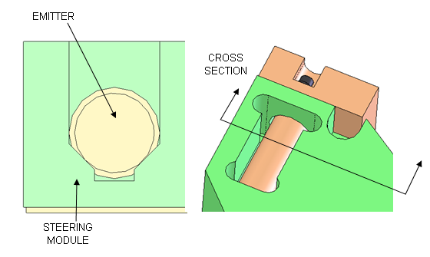
Figure 6: Cross-section for emitter v-groove.

The Steering Module will be mounted in the same manner that the mirror will be mounted to the Steering module. Small lapped pads will be used to mount the Steering Module to the laser bench. A pin and slot will be added to the bench so that the Steering Module is located accurately to the laser bench. The tolerances on these mounting features will be included in the tolerance analysis for the wedge design. Three #4-40 bolts will be used to fasten the Steering Module to the laser bench.

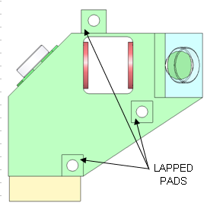
Figure 7: Bottom view of the Steering Module

The detail included in this preliminary design was necessary to determine the feasibility of fitting within the allocated volume. All the models created to this point represent volume allocations for each sub-component. The next step of the design is to analyze all components within the system. Features will be added to the existing components as necessary.

Open Items for final design review:
- Vibration analysis
- Tolerance study (after Steering Module finalization)
- Select wedge material
- Design mirror mount to fit within allocated volume
- Size all springs for 20G shock load
- Further define thermal analysis boundary conditions, perform thermal analysis
- Relate results for Thermal analysis to boresight error

Appendix A: Steering Module ICD
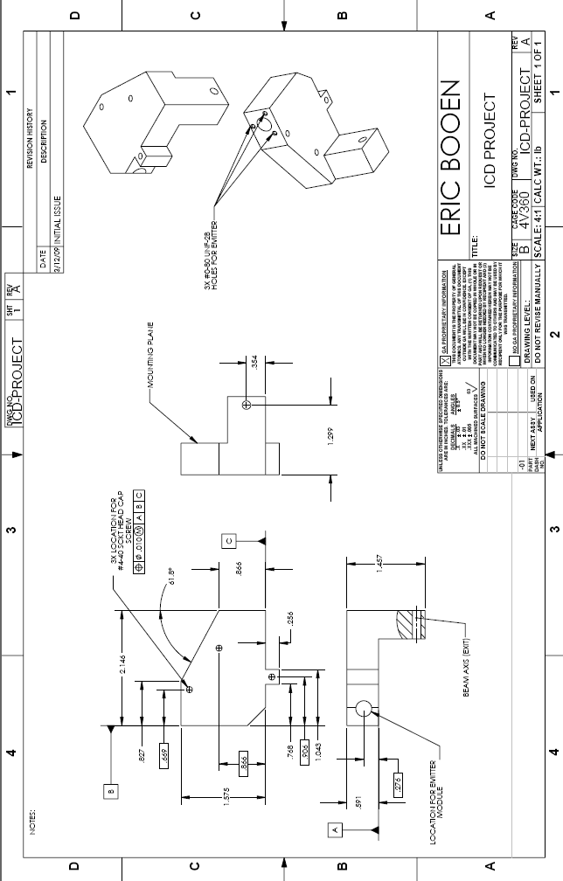
APPENDIX B: Emitter ICD


