What’s different about Ultraviolet and Infrared optics ?
by R.Barry Johnson
  - SYNOPSIS by TAYABALY Kashmira

Introduction:

This publication mainly addresses optical designers, fabricators and assemblers. R.Barry Johnson provides in this paper a practical overview of the similarities and differences existing between ultraviolet (UV) and infrared (IR) optics in terms of material availability, surface finish, mechanical and optical fabrication techniques, housing and mounting materials, alignment but also test and cost.
His analysis reveals that one will have to cope with many more difficulties in the ultraviolet than in the infrared and so, for each sections mentioned before.

Optical materials:

The availability of optical materials is highly dependent on the wavelength one works at. Wavelength domain can be divided in sub sections as it is shown in figure 1:
Figure 1- Wavelengths sub-sections

The number of optical material available drops significantly when one reaches very low or very high wavelengths (UV or IR) as one can see in figure 2 . That constitutes a major limitation in the design of optics at those particular ranges of wavelengths and more particularly in the UV where the choice in material is highly restricted. Fused silica and calcium fluoride are the most commonly used materials for their interesting properties adapted to work in UV. Fused Silica is cheap and thermally stable but has a cut-off at 170 nm and gets damaged at high intensity, while Calcium Fluoride has a cut-off wavelength deeper into the UV (123 nm) and is resistant to Fluorine corrosion but it can be easily broken and is hygroscopic.
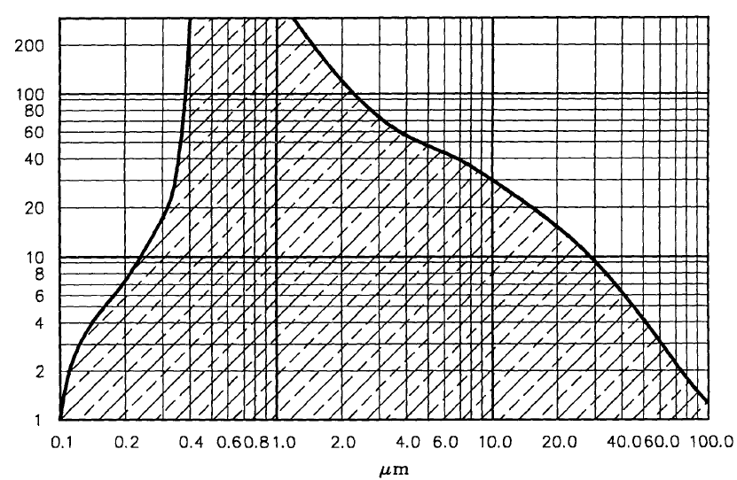
Figure 2- Approximate distribution of optical materials available at wavelengths from UV to IR.
As a result, an optical system working in the UV will require more optical components to mitigate this lack of diversity. However, there will be less surface reflection losses in UV, since materials used in this domain have smaller indices of refraction. Moreover, materials working in the UV are more dispersive than in the infrared. Besides, as much as one might have to confront internal absorption with high power infrared optics, one can deal with solarization issues in UV for microlithography for example.
Table 1 gathers optical materials commonly used in both UV and IR.

Ultraviolet | Infrared
Fused or synthetic Silica | Germanium
Calcium Fluoride | Silicon
Lithium Fluoride | Sapphire
Fluorocrown glasses | CVD
Schott Ultran Series for UV | ZnSe
 | ZnS
 | Chalcogenides
 | Calcium aluminate glasses
 | Germanate glasses
 | Metal fluoride and oxides
Table 1- List of materials commonly used for Ultraviolet and Infrared optics.

Structural materials:

Although materials used in IR can be both glasses or crystalline elements, working in UV only offers to deal with crystalline elements and CTE and dn/dT coefficients are key in the selection of the optical material for the design. Table 2 provides a few examples of materials CTE or $\frac{dn}{dT}$. These two coefficients lead to defocus δ when a change in temperature ΔT appears in the set up, such that:
$$δ=\left[\frac{- f}{n-1} \frac{∂n}{∂T}+αf+αL\right]∆T$$
With f: initial focal length of the lens and L: length of the housing for the lens.
And since Rayleigh criterion for resolution R and depth of focus D are dependent on wavelength and that numerical aperture NA of systems in UV and IR are comparable, then, at shorter wavelengths, the requirements on focus stability become tighter for UV (about 30 times tighter than in IR).
$R= \frac{0.61 λ}{NA}$ and $D= \frac{±λ}{2(NA)²}$
Therefore, to keep the UV system into focus one will need to introduce active means, such as piezoelectric components while passive means are tolerable in IR under certain precautions in the way the materials are chosen to cancel the shift in focus related to temperature change. Consequently, UV systems are much more complex than IR optics for a similar task.

Materials | CTE α (ppm/°C) | dn/dT 10⁻⁵/°C
Germanium | 6 .1 | 6.7
Silicon | 4.2 | 3.9
Sapphire | 6.7^{P} -5^{S} | 1.31
ZnSe | 7.8 | 6.1
Chalcogenides | 13 | /
Fused or synthetic Silica | 0.5 | 0.81
Calcium Fluoride | 24 | -9
Lithium Fluoride | 37 | -1.6
Table 2- Coefficient of thermal expansion and indices dependant on temperature for some optical materials used for IR and UV optics

Lens configuration

By comparing several optical set up respectively designed for infrared and ultraviolet optics, it is noticeable that UV optics have smaller FOV than IR optics and tighter tolerance on field flatness and distortion. Also, generally more complex than IR optics, UV systems require more precision and tighter tolerance as far as mechanical tolerances in lens housing are concerned. Indeed, tolerances can be as low as 0.5 µm in UV while it is usually higher than 10µm in IR, therefore UV systems require diamond turned housing and alignment on air bearing table.

Coating

Fewer coating materials are available in UV than in IR system and even fewer for wavelengths under 250 nm. In this range only band pass filters are feasible but they are difficult and expensive to make. Indeed, because the temperature at which the coating is applied is high, it generates mechanical stress in the material when it cools down. This stress generates tension for the few materials available for UV optics, and this tension can modify enough the flatness of the surface to make it out of the flatness specifications. Moreover, coatings are sensitive to change of temperature and humidity, so a small change of these environmental parameters could result in tension generation on the substrate surface and therefore, moving it out of its flatness specifications.
Table 3 shows some materials that can be used for coatings for both UV and IR domains.
Ultraviolet | Infrared
Enhanced aluminum (far and deep UV spectrum) | gold
 | Aluminum
 | Enhanced silver
Table 3- Materials used for coating in IR and UV

Fabrication and test:

UV optical surfaces requires greater care and quality than what one would specify for IR optical surfaces. Indeed, typical surface figure requirement is λ/4 which means about 91 nm in UV and 2500 nm in IR. Therefore, while only a diamond turning method is sufficient to manufacture IR optical surfaces, the process for UV optical systems is quite longer to ensure low scattering properties and the lower surface roughness the higher are cost and schedule for its fabrication (cf figure 3)
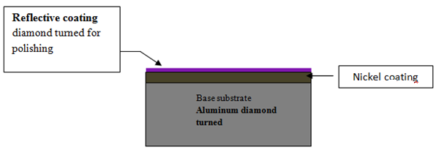
Figure 3- Surface finish process for UV optics

The same difficulties are encountered when testing the lens in the UV. It is harder to test UV optics and measure scattered flux. Moreover, atmospheric absorption increases when wavelengths decrease, consequently, special measurement conditions are required such as a vacuum environment to test UV optics.

Conclusion

Differences between UV and IR optical components are directly related to their high difference in wavelength but also to the difference in the number and quality of material available for each domain. For UV, it is required to maintain the system in a very narrow temperature bandwidth and clean room while IR optics operate over a broad temperature range in hostile environment. And while polarization and partial coherence doesn’t matter much in IR, their influence in UV is significantly greater.
But IR optics faces narcissus problem, that is to say image non uniformity due to the detector seeing its own cold reflection.

REFERENCES

- Johnson, B.R., 1992. What’s Different about Ultraviolet and Infrared Optics? SPIE Critical Review Vol. CR43, Optomechanical Design, ed. P.R. Yoder, p.61-75.
- Lau,A.S. “The Narcissus effect in infrared optical scanning system” in Stray-light problems in optical systems; Proceedings of the Seminar, Reston, Va., April 18-21, 1977. (A78-40270 17-35) Bellingham, Wash., Society of Photo-Optical Instrumentation Engineers, 1977, p. 57-62.
- Collier, D., Schuster, R., 2005. How to buy UV optics, Opto-Laser Europe, http://optics.org/cws/article/research/21870.
- Uwe Wielsch, Kurt Kanzler and Tim Lindsey, 2011, “UV Optics: Calcium fluoride micro-optics improve DUV excimer laser systems.
- J.H Burge “Introductory optomechanical engineering”, lecture notes 2011.

