Introduction to Thermal Circuits for Steady-State, One-Dimensional Heat Transfer

Abstract
Assuming steady-state, one-dimensional heat transfer via conduction and/or convection modes, expressions are derived for thermal resistances across planar and cylindrical interfaces. Series and parallel thermal network models are discussed (emphasizing similarity to electrical circuit theory). Two example applications are given, one further illustrating similarities to electrical circuit analysis techniques, and one illustrating the competing effects of conduction and convection in minimizing heat transferred to a refrigerant in an insulated pipe. Various extensions to general thermal network theory are briefly surveyed.

Introduction

Thermal conduction and convection are often phenomenologically introduced in first-semester optomechanical courses. Respective expressions governing the relation between heat flux, in 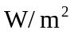, to either a linear material’s temperature gradient (conduction) or the difference in surface and ambient temperature (convection), are typically applied to as many as two layers and rarely considered for more composite systems (multi-layered and involving both conduction and convection).

At the same time, a typical prerequisite for understanding optomechanical system performance is exposure to system modeling. Often, this has been introduced in the form of network theory for direct current electrical circuits. Such provides a well established analytical framework for determining currents and voltages in respective loops and nodes using the appropriate Kirchoff law. Rarely would one limit the consideration of electrical circuits to only one or two resistor networks. Instead, complex systems are shown to be reducible to Norton/Thevenin equivalent circuits, which capture overall system performance in as little as one or two parameters. A key building block of this framework is Ohm’s law, providing the basis of the electrical resistance concept.

Similarities between these two different mechanisms (heat transfer and charge transfer) suggests that a similar network model could also apply to thermal networks. These thermal networks would then be subject to the same principles of network theory as are electrical circuits, with the appropriate modification of what each variable represents (e.g. current as either charge flow or heat flow). Kirchoff’s laws for summing voltages about a loop or currents at a point would then equally apply to thermal circuits.

The goals of this paper are as follows:
- lay the foundation for thermal network theory (for special cases of conduction and convection modes across planar and cylindrical walls),
- derive appropriate expressions for thermal resistance,
- describe the conditions for which series and parallel thermal models are appropriate,
- work through two typical examples of thermal network problems, and
- survey extensions of thermal network theory beyond the principles/applications covered here.

Fundamental Heat Transfer Principles

Before deriving thermal resistance expressions, some fundamental principles of heat transfer will be briefly presented. It is assumed the reader has a qualitative understanding of conduction and convection heat transfer modes. In-depth explanations of physical mechanisms by which these modes occur, as well as the validity limits of transfer expressions, are given in [1], chapter 1.

Pertinent heat transfer modes: The primary forms of heat transfer are conduction, convection, and radiation. Within the scope of this paper, only conduction and convection are considered.

Fourier’s law of conduction relates heat rate q (in Watts) within a linear medium of conduction coefficient λ, cross-sectional area A, and temperature distribution 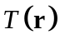, to the temperature gradient as follows:

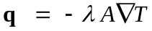 (1)

Newton’s law of cooling relating one-dimensional convective heat flow (along arbitrary linear dimension x) 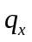from a surface to the difference between surface and ambient fluid temperatures (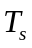 and 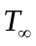, respectively) through a proportionality constant h, as follows:

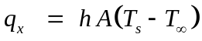 (2)

Note that h depends on a variety of parameters governing a specific flow condition (fluid density, viscosity, speed, turbulence, etc.). The subscript on indicates its reference to fluid temperature at distances far from near-surface boundary-layer temperature variations. Note that each of these laws may be expressed as heat flux, 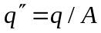.

Heat diffusion equation: The heat diffusion equation governs the time and spatial transfer of heat in a system. This “continuity equation” relates a medium’s heat generation 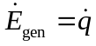, net (inward) power transfer 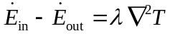, and net stored energy rate of change 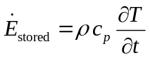 (with density ρ and specific heat 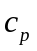) at a point according to:

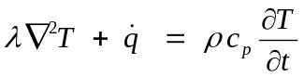 (3)

Equation (3) can be understood in terms of an energy balance at an infinitesimal control volume: 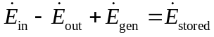.

Simplifying Assumptions and Coordinate Setups

This section modifies the general form of (3) for specific flow conditions and geometries, producing spatial temperature distributions and heat rates.

Steady-state, source-free conditions: Neglecting temporal temperature changes (and thus assuming temperature at each location in the media of interest does not vary with time), we set 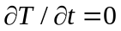 in equation (3). We furthermore restrict attention to media without time-dependent heat sources (or sinks) and thus set 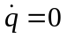. With these two restrictions, the heat diffusion equation reduces to:

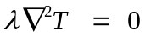 (4)

Now consider solutions to (4) for two specific coordinate setups.

1D heat transfer through planar wall: Assuming the Cartesian geometry of a planar wall (Fig. 1-A) in which the primary direction of heat flow occurs parallel to the x coordinate axis, we reduce the Laplacian of equation (4) to:

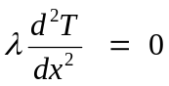 (5)

Assuming this wall has boundary conditions 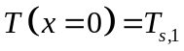 and 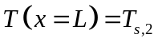, we directly integrate equation (5) to produce a spatial temperature distribution according to

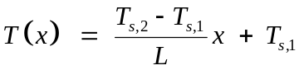. (6)

This temperature distribution induces the following conductive heat flow:

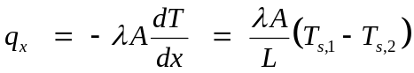. (7)

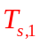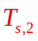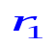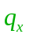
Medium: λ, cross-sectional area A
Distance x
Temperature T
L
Distance r
Temperature T
Medium: λ, length L
(into the page)
Figure 1: System geometries: (A) planar wall (left), (B) cylindrical wall

1D heat transfer through cylindrical wall: Assuming the cylindrical geometry of Fig. 1-B (where only radial heat transfer occurs across the medium), equation (4)’s Laplacian takes the form

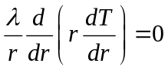. (8)

Directly integrating this expression subject to boundary conditions 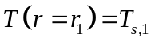 and 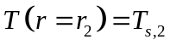 yields the following spatial temperature profile:

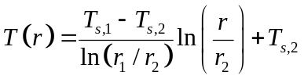 (9)

This temperature variation gives rise to conductive heat flow via Fourier’s law:

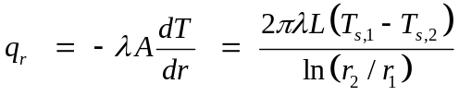. (10)

Note that the radial-location-dependent cross-sectional area in this previous expression is given by 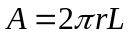.

Expressions for Resistances

Recall from circuit theory that resistance  across an element is defined as the ratio of electric potential difference 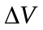 across that element, to electric current I traveling through that element, according to Ohm’s law,

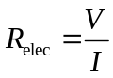. (11)

Within the context of heat transfer, the respective analogues of electric potential and current are temperature difference 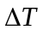 and heat rate q, respectively. Thus we can establish “thermal circuits” if we similarly establish thermal resistances R according to

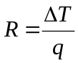. (12)

We now consider specific expressions for R based on results for the two geometries specified in the previous section.

Planar wall conductive resistance: Again referring to Fig. 1-A and the result in equation (7), we see that thermal resistance may be obtained according to

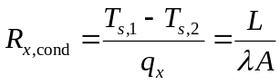. (13)

Cylindrical wall conductive resistance: Referring to Fig. 1-B and equation (10), we obtain conductive resistance through a cylindrical wall according to

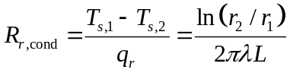. (14)

Convective resistance: The form of Newton’s law of cooling, in equation (2), lends itself to a direct form of convective resistance, valid for either geometry.

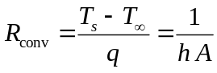 (15)

Series and Parallel Thermal Networks

With expressions for calculating thermal resistances in hand, we move on to the important task of choosing appropriate models for thermal networks. The utility of thermal resistances exists in the ease with which otherwise complicated thermal systems are modeled. This section considers series and parallel thermal networks, drawing analogies to circuit theory’s rules for equivalent resistance. For simplicity, only Cartesian geometries are considered.
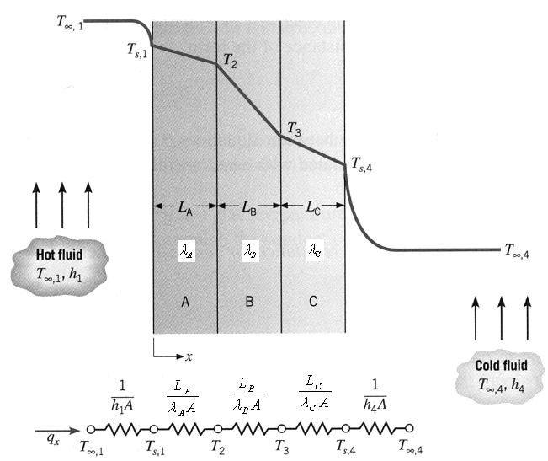
Series networks: Recall from circuit theory that resistors in series produce an equivalent resistance between input-output terminals that is the sum of individual resistances, owing to the fact that each individual resistor has the same current flowing through it.

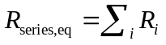 (16)

Likewise, systems in which multiple elements are intercepted by a single heat flowline are modeled serially. Fig. 2 illustrates an example series model and circuit schematic for a double-exposed, layered window (note the presence of both conduction and convection transfer modes). In this example, the equivalent thermal resistance would be the sum of each resistance shown, and would relate overall temperature difference across the network according to
Figure 2: Layered planar wall (from [1])

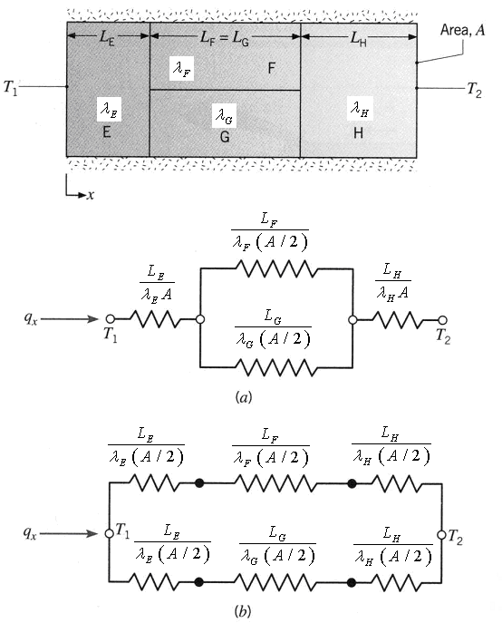
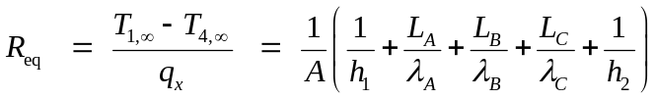. (17)

Parallel networks: Recall that electrical resistors in parallel produce equivalent resistance

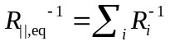. (18)

Such a model exists when multiple current paths exist between two nodes. A similar situation occurs in thermal networks when two paths (through different media) exist between two points of the same temperature. An example system is shown in Fig. 3, with two equivalent schematics. The equivalent resistance between the left and right faces of material F (or G) is thus

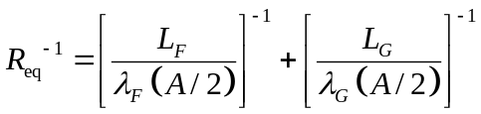 (19)

Note that this equivalent resistance will be less than either individual component.
Figure 3: Parallel conduction network (from [1])

Note that this circuit model is valid only when heat flow is assumed approximately one-dimensional (if significant heat flow occurred vertically between materials F and G, the resistors-in-parallel model would be invalidated).

Example Problems

This section applies thermal resistance principles in the analysis of two example problems, one for each geometry of interest. The first example will extend our modeling capabilities by adding a current source to a flux-based network with specified surface contact resistance to model an epoxy bond. The second example demonstrates performance tradeoffs involved with scaling geometrical form factors in search of optimum performance. These examples introduce other concepts not mentioned previously and demonstrate the analogous relationship between thermal and electrical circuit analysis.

Example 1: Comparing performance to specification (max temperature):

- Problem statement:
  - A thin silicon chip and an 8-mm-thick aluminum substrate are separated by a 0.02-mm-thick epoxy joint (whose thermal resistance can be approximated as a contact resistance of 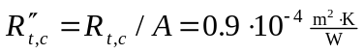)
  - The chip and substrate have their exposed surfaces cooled by 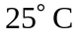 air, providing a convection coefficient of 100 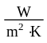.
  - If the chip dissipates 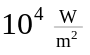 under normal conditions, will it operate below a maximum allowable temperature of 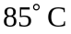?
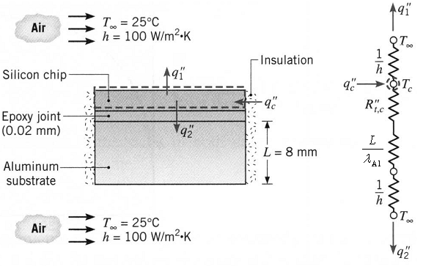
- System diagram/schematic: See Fig. 4 at the right. Note that currents are shown in terms of fluxes (in 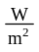), denoted with double-primes () since areas are not specified. This requires resistances to be stated in terms of 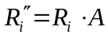. Note particularly how the 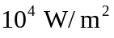 chip dissipation is modeled as a flux source.
- Analysis:
  - We seek to find whether the calculated value of 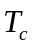 remains below the specification.
Figure 4: Problem 1 diagram/schematic (from [1])
  - We start by noting, just as in electrical circuits, that the total current entering the node must equal the current leaving it:
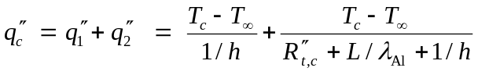 (20)
  - Solving for yields 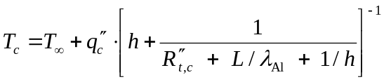.
  - Substituting all known values (with 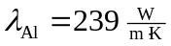) gives 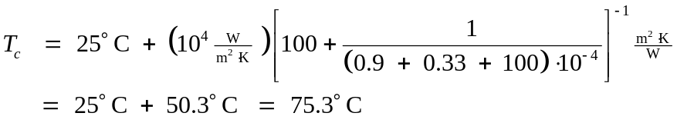
  - Therefore, the chip will operate below the maximum allowable temperature.

The next example considers the following two competing effects in a cylindrical insulation system as the outer insulation radius r increases:
- The increase in conduction resistance 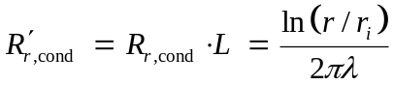
- The decrease in convection resistance 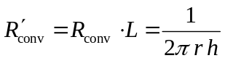 (due to a larger exposed outer area).

Example 2: Scaling effects on system geometry

- Problem statement:
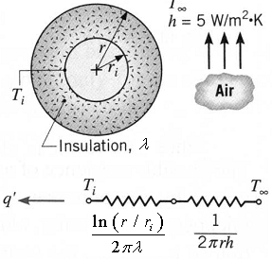
  - A thin-walled copper tube of radius is used to transport a low-temperature refrigerant and is at a temperature that is less than that of the ambient air at around the tube. Is there an optimum thickness associated with application of insulation to the tube?
- System diagram/schematic: See Fig. 5 at right. Note that per-unit-length currents 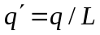 and resistances 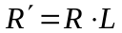 are used and that the system is modeled as a serial, radial system.
- Analysis:
Figure 5: Problem 2 diagram/schematic (from [1])
  - Note that the optimum value of r will minimize current 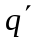delivered from the environment to the refrigerant (or equivalently, since 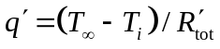, the optimum r will maximize resistance 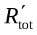 between the environment and refrigerant).
  - Note that total resistance is calculated as 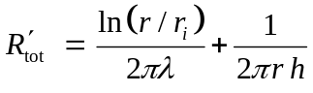 and is thus a function of outer radius r.
  - We find extrema of 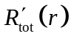 by calculating 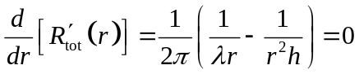. This extremum occurs at 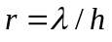.
  - This extremum produces {minimum, maximum} depending on whether 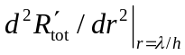 is {positive, negative}.
  - We find 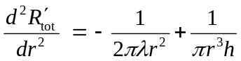 and 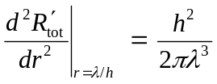 which is always positive, and hence the extremum effectively minimizes (thus maximizing the current to our refrigerant, the opposite of the desired effect).
  - Since 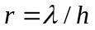 was the only extremum of , we conclude that an optimum thickness does not exist.
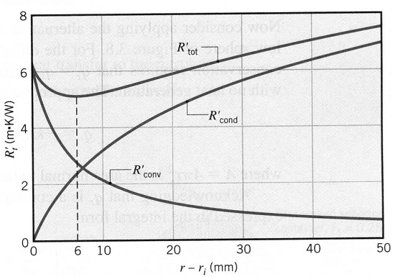
An example plot of 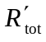, with contributions from conductive and convective components, is shown in Fig. 6, evaluated for values 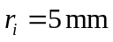, 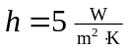, and 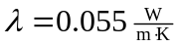 (producing a critical radius 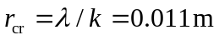such that 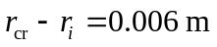). Note that, beyond the critical radius, the performance increases with increasing insulation radius.

Figure 6: Effect of total resistance for increased insulation thickness (from [1])
Extensions not covered here

This discussion has limited scope to concepts/applications most likely to be of immediate interest to the audience. A more generalized treatment of thermal network theory is found in [1], chapter 3. Some extensions of this theory beyond the concepts covered in this paper include:

- Thermal resistance of a spherical shell: 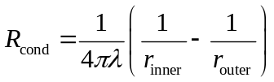.
- Incorporation of heat generation () effects in a circuit.
- Radiative heat transfer, occurring according to the Stefan-Boltzmann law 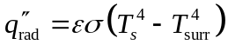, can be expressed as 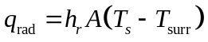 where radiation heat transfer coefficient 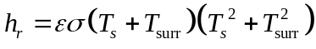 has strong temperature dependence. For such cases, thermal resistance may be defined similarly to the convective mode: 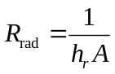. This usually exists in parallel with the convective resistance at a surface (when radiative effects are not negligible).
- Heat transfer from extended surfaces (cooling fins, etc. where the 1D flow assumption is invalid) often have tabulated expressions for temperature distribution 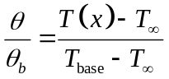 and heat transfer rate 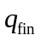 based on geometry and fin boundary conditions. Such a table (for fins of uniform cross section) is given in Table 3.4 of [1]. A figure-of-merit often used for fin geometry performance comparison is the fin thermal resistance, 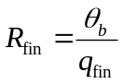 (a higher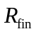 value indicates poorer cooling performance).
- Under certain conditions, cylindrical and/or spherical geometries with large radii can be approximated as planar (flat) walls.

Summary

The concepts of conductive and convective thermal resistance were derived from fundamental laws governing heat transfer and the heat diffusion equation. Two specific geometries (planar and cylindrical walls) were considered in obtaining explicit forms for conductive resistances. Thermal network modeling was then covered, emphasizing the conditions appropriate for serial and parallel networks. Two examples were then used to reinforce the developed concepts, one drawing further similarity between the analyses of thermal and electrical networks, and one considering the tradeoffs in conductive and convective heat losses as geometry changed. Extensions were briefly surveyed.

In conclusion, we have successfully outlined the process of setting up and analyzing steady-state, 1D heat transfer problems for the geometries and modes indicated. The analytical capabilities provided in this discussion are deemed worthy tools for the system engineer, as system sensitivities (such as change in interface temperature for incremental changes in thicknesses, etc.) and overall system performance (whether a tradeoff in thermal performance balances the risk of other factors, such as mechanical stiffness) can now be achieved by recycling the analytical framework used in linear circuit theory.

Reference

- F. P. Incropera, D. P. DeWitt, T. L. Bergmann, A. S. Lavine, Fundamentals of Heat and Mass Transfer, 6th Ed., John Wiley & Sons Inc., 2006.

