Steven Hearon
OPTI521, Project #2, Tutorial
December 7, 2009

Subject: Vibration Isolation in Electro-Optical Spacecraft

Table of Contents
- Introduction
- Background: Two telescopic spacecraft considered
  - Ikonos
  - Hubble
- Sources of Vibration
  - Momentum wheels and reaction wheels
  - Slewing to acquire object of interest; deceleration; settle time
  - Motors for solar array and communications antenna
  - Cryocoolers for detectors
  - Thermal change as s/c enters or exits umbra
- Analyzing Vibrations
  - Basic equations of vibration
  - Effects of Vibration on an Image: Boresight
  - Effects of Vibration on an Image: Primary Mirror oscillation
  - Effects of Vibration on an Image: Primary to Secondary Mirror distance variation
  - Finite Element Analysis Tools

- Conclusions
- References

- Introduction
This report discussing vibration in electro-optical spacecraft: the sources of vibration, methods of analyzing and isolating vibration, and the effects of vibration on the image. There was insufficient time to organize the material to the author’s liking. Hopefully the Powerpoint presentation will have a better structure.

- Background: two telescopes considered
a. Hubble Telescope. 2.4 meter aperture primary mirror, fore-optics of Richey-Chrétien (two-mirror) design. RC design corrects 3rd-order Spherical Aberration and Coma. Suite of astronomical sensors. Staring Arrays. Half FOV of largest FOV instrument for Hubble (the wide-field camera) is about 12 arcminutes. Spacecraft uses 4 reaction wheels for attitude control. Basic mode of imaging is to stare at a fixed point in inertial space for up to hours at a time, collecting light of very distant objects. [1]

b. IKONOS. 0.7 meter Primary Mirror, 10 meter focal length, Three-Mirror Anastigmat (TMA) design controls SA, Coma, Astigmatism, and Field Curvature. Attitude is measured by two star trackers and a sun sensor, and is controlled by four reaction wheels. Location knowledge is provided by a GPS receiver. Spacecraft mass = 817 kg. Power is 1.5 kW, provided by 3 solar panels. Uses pushbroom detector technology, 6500 lines/second for Panchromatic data. Pixel size is 12 um for PAN and 48 um for Multispectral imagery. Imagery is captured across a swath of 11 to 13 km. Choice of 10,13,18, 24, or 32 TDI stages in PAN. Primary mirror mass is reduced by cutting a honeycomb pattern into the back side of the PM using waterjets. Entire spacecraft is slewed into the desired direction using reaction wheels. Structure is rigid; has high-frequency natural modes of vibration. [2]

- Sources of Vibration in Spacecaft
There are several sources of vibration that can enter the optical path of the telescope. Some of these occur with the normal housekeeping needed for maintenance of the spacecraft, and others occur during imaging. Figure 1 shows a picture of the Hubble spacecraft. (The captions are in Italian; however, a key is given in the caption explaining the translation.) [3]
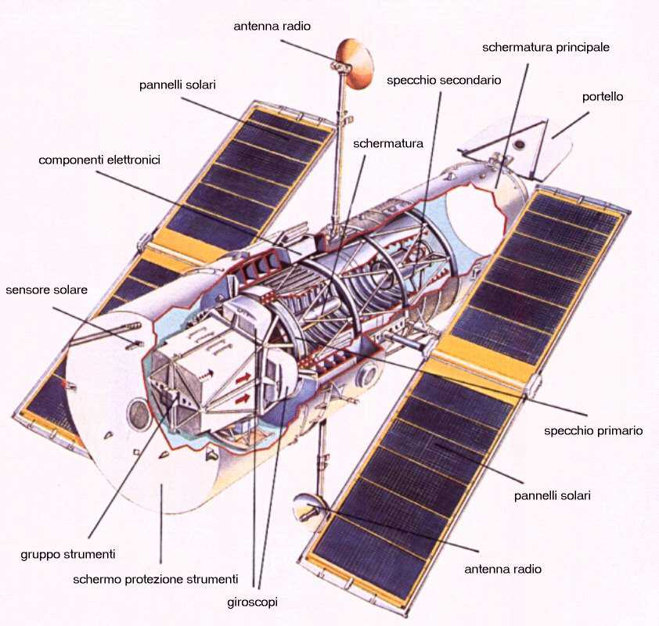
Figure 1 Diagram of the Hubble Space Telescope, with some structures identified in Italian. Key: antenna radio = communications antenna; pannelli solari = solar panels; conponenti elettronici = electronic components; sensore solare = solar sensors; gruppo strumenti = instrument group; giroscopi = gyroscopes; specchio primario = primary mirror; portello = thermal door; specchio secondario = secondary mirror

  - Reaction wheels and Control Moment Gyroscopes (CMG’s)
A reaction wheel is a type of flywheel used by spacecraft to change their angular momentum, or attitude. This is accomplished by having an electric motor attached to a flywheel, which upon spinup causes the spacecraft to turn the other way. Reaction wheels work around a nominal zero rotation speed. This is the mechanism used by the IKONOS spacecraft to point to an object and to scan during its pushbroom imaging mode. It is also employed in the Hubble spacecraft to change its attitude.
Another approach to attitude control is the control moment gyroscope (CMG). A CMG is essentially a big gyroscope. A motor moves the axis of the CMG relative to the spacecraft body, and by conservation of angular momentum, the spacecraft rotates in reaction to the CMG change of orientation. The CMG is much more energy efficient than the reaction wheel. However, the WorldView satellites are among the few remote sensing spacecrafts employing CMG’s. CMG’s are also used for attitude control in the International Space Station.
Unwanted vibration can occur if there is any residual imbalance in the CMG, or during attitude maneuvers using the reaction wheels.

  - Slewing to acquire object of interest
As an agile spacecraft slews to acquire its next target, it must decelerate to begin staring, or scanning, during the image acquisition. This deceleration causes the vehicle to vibrate. The imaging should not begin till the vibrations have damped down sufficiently to have no effect on the image quality.

  - Motors for solar array, communications antenna, cryocoolers, thermal door
Motors onboard the spacecraft are a source of vibration. The solar array motor maintains the orientation of the solar array normal to the solar direction to maximize energy. The communications antenna must point to either a ground station or to a relay satellite to downlink the data for ground processing and dissemination.
Some payloads have instruments that must be cooled (such as IR detectors). One method of cooling uses a cryocooler (a refrigerator).
The thermal door of the Hubble has a thermal door.
These motors must be considered as potential sources of vibration that can affect optical performance.

  - Sudden thermal changes
Sudden thermal changes in the spacecraft can induce vibration. When the spacecraft enters or exits umbra, this can result in a phenomenon known as “thermal snap” due to the sudden expansion or contraction of the materials. [4]

- Analyzing Vibration
  - Basic Equations of Vibration Transfer
Figure 2 shows a schematic diagram of an electro-optic telescope spacecraft structure.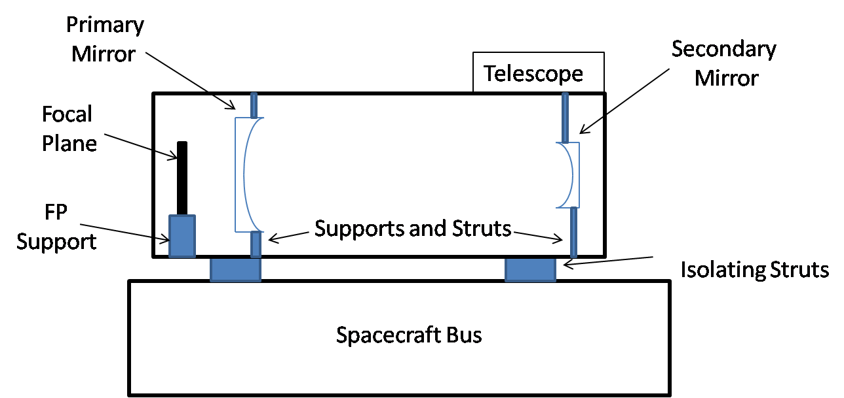
Figure 2 Diagram of a Spaceborne Electro-optic Telescope

In this figure, the Spacecraft Bus refers to the supporting spacecraft shell, which protects the instrument and performs the operations of energy generation, pointing, communications, and housekeeping. (For some electro-optic payloads, the bus is integrated with the telescope.) The basic equations of vibrational transfer between any two structures can be derived by considering the basic equations of motion between these structures. A schematic model is shown in Figure 3, from [5].
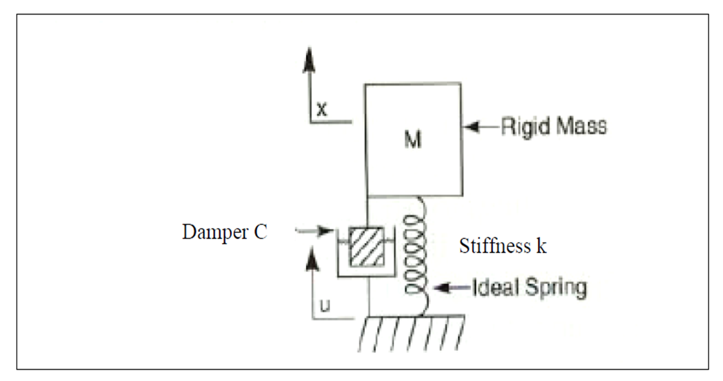
Figure 3 Vibrational Model, Copyright J. Burge, University of Arizona (Ref. [5])

We consider transference of energy from the larger structure (below, in Figure 3) to the smaller mass. This section follows the description given in the Burge notes of OPTI 521 [5]. The motion of the mass M is governed by the equation:
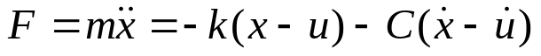 (1)
where x is the position of the mass M; u is the position of the larger structure below it, k is the spring stiffness; and C is the damping constant. If we define the resonant frequency of the mass M, in rad/sec, as
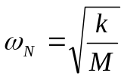 (2a)
We will also need to define the critical damping constant as
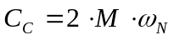 (2b)
and the critical damping ratio as
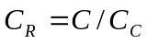 (2c)
In terms of these parameters, Eq.(1) can be solved for the ratio of the mass motion to base motion. Amplitude:
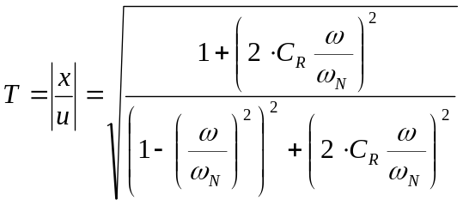 (3a)
Phase: 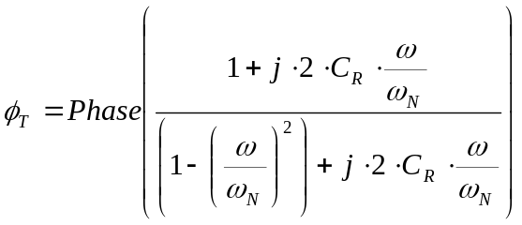 (3b)
The phase will approach 0 degrees for w << w_{N}, and it will approach 180 degrees for w>>w_{N}. Near the resonance the phase approximately equals 90 degrees, and the phase changes rapidly with w.
Figure 4 shows a plot of the transmissibility T versus frequency, for several values of the critical damping ratio (from [5]).
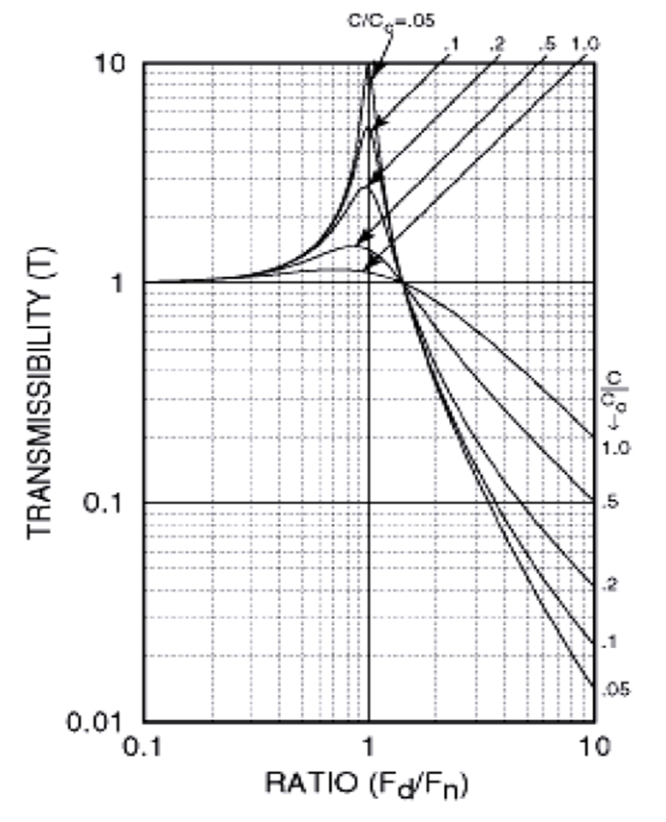
Figure 4 Transmissibility Curve (copyright J. Burge, University of Arizona [5])

The isolation provided by the isolating struts will attenuate vibrational energy at frequencies greater than about 1.414 f_{N}. Frequencies less than this will be amplified, particularly near the resonance at f_{N}. For our conceptual spacecraft of Figure 2, the entire telescope is subject to vibration that is brought about from the actions of the bus, from disturbances such as those listed in Section 3.
The Power Spectral Density curve describes the typical vibration environment in acceleration units, in units of g^2/Hz. The disturbance environment is specified in terms of this PSD curve. Each contributor to vibration will have a PSD bounding its contribution.

  - Effect of Vibrations on Imaging: Boresight
For some systems, isolating struts are used to reduce the vibration of the telescope relative to the bus. The isolators will have a transmissibility curve similar to that shown in Figure 4. In this case, the entire telescope boresight will be perturbed due to the residual motion transmitted from the bus to the telescope structure. Then the total acceleration environment will be given by
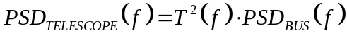 (4)
The PSD for the telescope, Eq.(4), is expressed in terms of acceleration (g^2/Hz). However, a more useful metric is the RMS boresight variation, in units of microrad^2/Hz. An accurate calculation of the boresight PSD requires an FEA model such as NASTRAN. However, we will attempt a highly simplified calculation of this effect. Referring to Figure 2, a boresight error will be induced if the two isolating struts are vibrating out of phase. Converting the PSD of the telescope to a displacement PSD yields 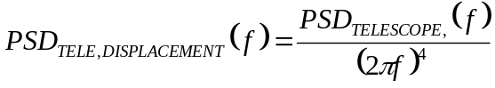 (5)
And to get an angular boresight displacement requires dividing the telescope displacement PSD by the square of the telescope length (approximately). Thus the boresight PSD is very roughly given by
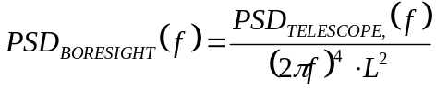 (6)
in units of rad^2/Hz, where L is the approximate length of the telescope. Some of the vibrational modes may not, in fact, induce pointing error. In any case, FEA models are needed to accurately calculate the boresight PSD.

  - Effect of Vibration on Imaging: Primary Mirror Vibration
Referring to Figure 2, the telescope structure can transmit vibrational energy to its constituent parts, such as the primary mirror, the secondary mirror, and the focal plane. As discussed in the OPTI521 notes [5], if the lowest resonant frequency, f_{PM}, of the primary mirror is known, as well as the Q of its resonance, the RMS primary mirror acceleration is approximately given by the Miles equation [5]:
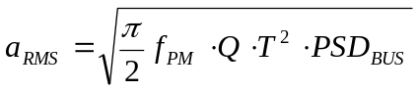 (7)
Note that the Miles equation is an evaluation of the square root of the area under the transmissibilitycurve (Figure 4). This can be converted to an RMS displacement as
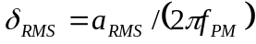 (8)
And once the RMS displacement is known, the corresponding Strehl ratio can be calculated to determine whether there is an effect on imaging. Typically, the PM is at a sufficiently high resonant frequency compared with the isolating struts that PM vibration is not an issue. The resonant frequency is given as the square root of the ratio of the effective stiffness to the effective mass of the object (Eq.2a). Materials chosen for the mirrors and other structures should be stiff and light, to keep the resonant frequencies high enough to attenuate vibrations.
The lowest resonant mode of the Primary Mirror will cause a low-order disturbance of the point-spread function, similar to a defocus.

  - Effect of Vibration on Imaging: Primary to Secondary Mirror Variation
One mode that can occur is variations in the optical path between the primary and secondary mirrors. This has a long baseline, and thus is more likely to have a lower resonant frequency than the primary mirror oscillations. This mode will thus be more likely to have observable effects on the image than the primary mirror oscillation. The primary effect will be a defocus of the image.

  - Finite Element Analysis Tools
Finite Element Analysis (FEA) tools are indispensible for estimating effects of vibration in electro-optic spacecraft. A FEA tool used at Lockheed Martin is NASTRAN. The major outputs of the FEA models are the natural frequencies and corresponding modes (shapes) of vibration of the structure.
The damping factors are actually quite difficult to calculate for structures in space. The materials tend to have low damping, and the damping itself may occur in the joints of the structure, which is difficult to analytically calculate. Often a low value of the critical damping ratio, such as 0.005, is used for lack of a better estimate.
Modal tests can be performed in which the damping is measured experimentally. It is, however, difficult to replicate the vacuum and zero-gravity conditions that exist in space. [4]
Once the FEA model of the structures is built, specific excitations, such as a deceleration maneuver or a running motor, are then applied to ascertain their effect on the structure. The time-dependent FEA model outputs can then be interfaced with optical codes such as CODE V or ASAP, allowing measurement of their effect on the optics train to be calculated.

- Conclusions
We have discussed some basic considerations regarding controlling vibrations on a spacecraft. The topic is vast.

6. References
[1] Nasa Hubble Space Telescope Web Site; Wikipedia
[2] Herbert Kramer, Observation of the earth and its environment: survey of mission and sensors, 2002
[3] Hubble Space Telescope site, Italy
[4] Conversation with Michael Garnek of Lockheed Martin Valley Forge
[5] J. Burge, University of Arizona, OPTI521 2009 Notes, Chapter 16, Vibration

