Mike Hemmat
OPTI 521
November 2011

Synopsis of Technical Report:

“Low cost, lightweight, large aperture, laser transmitter/receiver”
Robert E. Parks
Lian Zhen Shao

Proc. Of SPIE Vol. 1113, Reflective Optics II, ed. D G Korsch (Oct 1989) Copyright SPIE

Abstract

The purpose of this technical report is to evolve the standard design practice for building LIDAR telescopes or beam expanders. Current standards are presented with quantitative values and then directly compared to the improvements suggested. Parameters for determining improvement are cost, weight, and specifically cost per unit area of aperture.
Three primary advances are employed to achieve the improvements desired. First, use of a lightweight borosilicate primary slumped mirror to reduce weight and cost. Second, due to the fact that the system operates in a basically paraxial manner, the primary mirror design tolerance and build complexity is significantly reduced which results in cost savings. Third, exploitation of different structural material’s CTEs to passively maintain alignment during thermal excursions.

Optical Design

Primary mirrors are traditionally shaped and polished from a solid blank. The first major system improvement is to instead use a lightweight borosilicate primary mirror slumped to the net shape of the desired curvature. This method of producing the largest optic in the system reduces the mass of the primary by approximately 75%. When evaluating the optical performance, it is shown that due to environmental perturbations, a 3 arc second field of view is the best that can be achieved without more sophisticated field distortion compensation. Using this information and the fact that the system basically operates in the paraxial regime, it is possible to make the primary mirror spherical and not aspherical. An aspherical primary would need much more labor to polish in the 125 microns of asphericity. Then testing the mirror would require either a full aperture flat or a fast null lens. Both of these options are much more expensive to test than the solution presented. By making the primary a spherical mirror then the secondary is designed to be a Mangin mirror of fused silica.
The secondary mirror must have an aspheric shape for near diffraction limited performance, but because the secondary mirror is much smaller than the primary, testing the shape the mirror is much cheaper and easier. The suggested test method is to use a simple Offner null lens with two elements each about 50 mm in diameter. Due to the performance required from this system, the alignment tolerances are fairly loose with the exception of the primary to secondary despace.

Mechanical Design
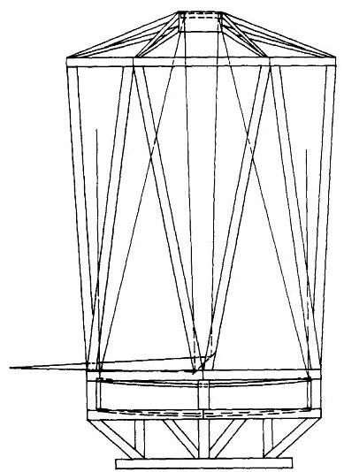
Figure 1: Tubular steel telescope structure

Figure 1 illustrates one possible mechanical design for mounting the telescope mirrors. While the construction of the assembly is straightforward, maintaining alignment over thermal perturbations is difficult. The innovation here is to use two common metals with different coefficients of thermal expansion. The two metals considered are steel and aluminum, both readily available and relatively cheap. The idea is to create most of the structure out of steel with the exception of the secondary mirror head ring. Because the CTE of Aluminum is greater than that of steel, shorter length will expand more or less evenly under the same thermal stress. To calculate the ratios of length with regard to CTEs, we use the following geometric argument.

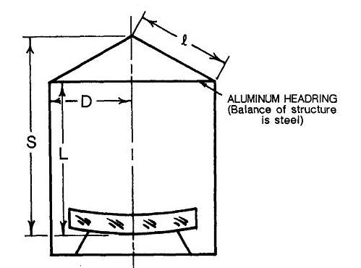
Figure 2: Model of athermal telescope structure

$$l^{2}={\left(S-L\right)}^{2}+D^{2}$$
$$l ∆l= -\left(S-L\right)∆L+D∆D$$
Where $∆l= α_{steel} l$
$∆L= α_{steel} L$
$∆D= α_{aluminum} D$
$$L= \frac{S^{2}+D^{2}(1-\frac{α_{steel}}{α_{aluminum}})}{S}$$
Using the parameters of a comparable UV system the value of L is about 91.5% of S to achieve an athermal structure.

Conclusion

The direct comparison of the lightweighting concept to the overall system is shown in Table 1. The most sensitive parameters have been addressed. However, for a more rigorous computation of the thermal performance of the system, the expansion and radius change of the primary and the index variation of the secondary must be accounted for even though the effects are small. It should also be noted that because the primary is significantly lighter, the self weight deflection is greatly reduced.

Primary Aperture | 1.0 m | 1.5 m | 2.0 m
Telescope with solid primary (approx) | 680 kg | 2180 kg | 5220 kg
Telescope with lightweight primary (approx) | 190 kg | 560 kg | 1520 kg
Table 1: Compare between original and new design at 3 aperture diameters
It has been shown that not only will the overall system be significantly lighter with the modifications described, but also much lower cost to manufacture and test. This technology is useful for any design that requires a telescope or beam expander where the field of view is small and weight and cost are issues. LIDAR was the driver for the design specs, but any telescope would benefit. In fact, the optical analysis was done considering UV light, and still hold for visible and IR radiation as well. This is important because most LIDAR is currently done in the Near IR.

