Synopsis of a published paper
“Design and fabrication of high performance relay lenses”
Yu-Hsiang Lai
Opti-521
November 2, 2009
Abstract
This article mainly deals with the design and fabrication of high performance doublets and triplets for relay lens applications. It emphasized on the important factors when building high performance optical systems, as well as
Introduction
Detailed design work will was not covered in this paper, and the designer has to make decisions on the selections of lens focal length, aperture, glass types, and the balancing of aberrations. This paper will only focus on the areas in genera that have a significant bearing on the overall performance of the finished lens, despite of the difficulty to design a diffraction limited lens for the applications mentioned in this paper.
Designing the System
It is more important to clarify the level of performance that can be achieved for the specific lens assemblies and the resultant optical system before getting down to the specifications on the design and fabrication. For systems similar to the ones described in figure 1, once the lens elements are hard mounted into a lens barrel and secured in place by means of a clamp ring, there will be no provision for adjusting one lens relative to another. Thus it is extremely crucial that all the parts which make up the lens assembly are of very high quality. The system will not be able to meet the expected performance if the parts are out of the tolerance range, both optical and mechanical. It requires a significant amount of time, considerable expertise and good documentations to make a system work, especially when the schedule and budget are tight. To manufacture a precision lens assembly the following ingredient are necessary and are show in figure 2. Each of these areas was discussed in the paper, considering various basic lens forms, performance, and sensitivity to small lens tilts and de-centers.

 | Optical System | Interferogram
Typical Triplet
Periscope System
Figure 1: Left: Optical systems with no adjustment. Right: System Quality
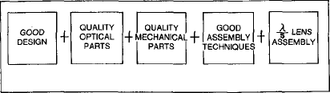
Figure 2: High performance lens ingredients
Two basic relay lens forms were shown in figure 3. The one on the left is the conventional doublet, the one in the center is the improved the doublet, and the one on the right is the triplet. There are two important items in each configuration. The first is that the air spaces and lens shapes remain relatively constant during the design. Secondly, as the secondary spectrum is reduced by using other than the normal glass types such as in the Improved Doublet and Triplet, the power of the individual lens elements increases, adding sensitivity to small tilts and de-centers.
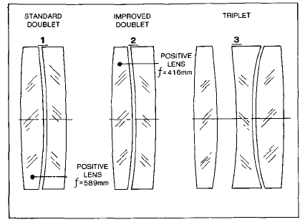
Figure 3: Basic relay lens configurations
The glass selection would be the first step in the entire design process. In order to obtain the peculiar partial dispersion characteristics for increased color correction, it is important to pick up something other than the ordinary glass. It is also important to ensure that the supplier has the proper size and homogeneity glass available during the design. Thermal coefficients, transformation temperature, stain classifications, and the workability of the glasses must also be considered within the target budget. The tradeoff between system performances against cost is always a tough task.
Tolerance always plays a huge part in any design and requires many years of experience. As illustrated in figure 4, only an experienced engineer who is familiar with optical and mechanical fabrication and assembly techniques would know how to make the lens work when tilts or de-centers is introduced into the system.
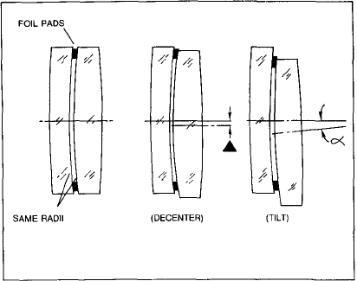
Figure 4: Tolerance Analysis
Figure 5 compares the three lens types mentioned earlier with regards to their state of correction, sensitivity, and diameter tolerancing.
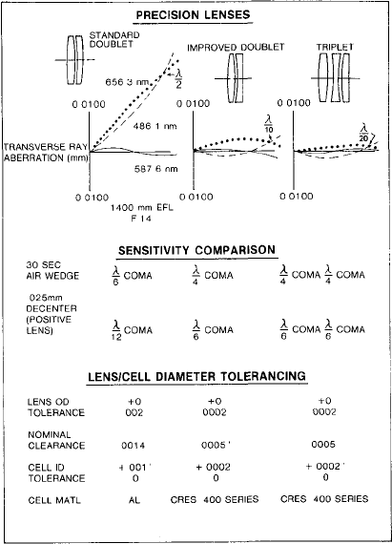
Figure 5: Lens Performance, sensitivity, and diameter tolerance comparison
The ability of a shop to evaluate a lens surface for small amounts of irregularity is also an important factor. The quality and availability of test plates, the possible amount of residual power during test, the skill of the opticians, and the diameter to radius ratio of the lens surface all need to be evaluated by the designer. An u\interferometer directly in the optical shop and used by the optician making the optics is a very powerful learning tool and allows additional insight into the manufacturing process.
Power and irregularity specification should be clearly listed when applying tolerances. When making high precision optics, the rework process of a lens surface that has a half fringe of excess power, would be a very costly and heartbreaking exercise.
Lens Spacer Fabrication
The most difficult part in the manufacture process is the lens spacer. A good spacer is one that is perfectly rounded, not elliptical, and whose faces are square to the optical system. The author introduced a method in which he has found good success. There are four major steps in this method. First, the spacer is roughly machined to near finish dimensions and heat treated. Second, the spacer is potted into a fixture as shown using a low melting alloy, and then bored to its final diameter. Third, a number of lens spacers are then slipped over a precision arbor and ground to the finished diameter. Finally, the spacer is placed into a precision ring and the top surface ground flat. The spacer is then turned and the opposite side ground flat and then turned once more and ground to the finished dimension. The entire process can be illustrated in figure 6.

Step 1 | Step 2
Step 3 | Step 4
Figure 6: Lens Spacer Fabrication procedure
Build the System
The most important factor in the assembly process is choosing the right person to do the job. He must be aware of the sensitivity of air spaces in the lens assemblies, the effect of small tilts and de-centers and an understanding regarding surface quality. An interferometer should be used to assess everything from excess clamp ring pressure to the effect of marginal parts. Figure 7 shows the lens assembly hour vs. lens speed or f-number. As we can see the faster the lens the more difficult it is to assemble.
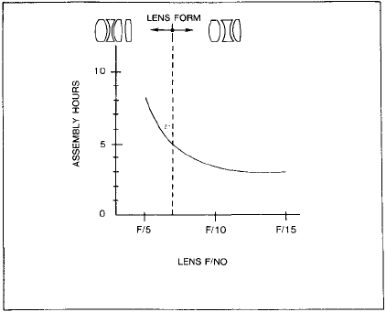
Figure 7: Lens assembly hour vs. Lens f-number
Conclusion
The most important thing to note during design is communication. The optical designer must make sure that all information flows to all areas such that a mechanical engineer, optical engineer, mechanical fabrication, inspection, purchasing and assembly can all work together flawlessly. The high performance relay lenses require not only a superior optical design but superior mechanical mounting techniques combined with excellent workmanship to achieve the desired system performance. The use of single point diamond machining technology have efficiently increased performance and reduced cost. Anyone who is interested in building any sort of optical system would definitely find this paper helpful to certain degrees.
Reference
- J.Burge, Class notes and lectures of “Introductory opto-mechanical engineering”, Fall, 2009

