Synopsis of Technical Paper:
“Method of calculating the alignment
Tolerance of a Porro prism resonator”
Jyh-Fa Lee and Chung Yee Leung
APPLIED OPTICS / Vol. 28, No. 17 / 1 September 1989 / p. 3691-7

Introduction

Laser resonators utilizing porro prism reflectors as opposed to the conventional mirror-mirror cavity are significantly more stable. This stability makes the porro resonator an ideal choice for a coherent light source in Laser Rangefinders where the stability of the bore-sight is paramount. However, like all things in the physical world, nothing is perfect. The paper of this synopsis explores the consequences of misalignment of the porro reflectors and the impact on output energy. The paper appears to be an extension of two other papers by the same authors detailing changes in pointing and shift of the mode axis., All three papers are relevant to the tolerance ofporro position in the resonator and could easily be combined into one paper. The subject of this synopsis was chosen because it references the other two.

The basis for quantifying alignment tolerances in this paper employs a ray tracing method to calculate the position of the oscillation axis through the active lasing medium. The authors assume that one porro is fixed and analyze the effects of perturbing the angular orientation of the 2nd porro. Taking the optical axis to be the z-axis, the effects of yaw (β – referred to as horizontal misalignment) and pitch (γ - referred to as vertical misalignment) on the 2nd porro are derived. The roll (θ) of the 2nd prism is directly related to the polarization of the beam and thus dictates the output energy of the laser at the cube polarizer (Fig.1, from p. 3694 of the paper). The θ–coordinate also plays a significant role in defining the oscillation axis and thus pointing effects.
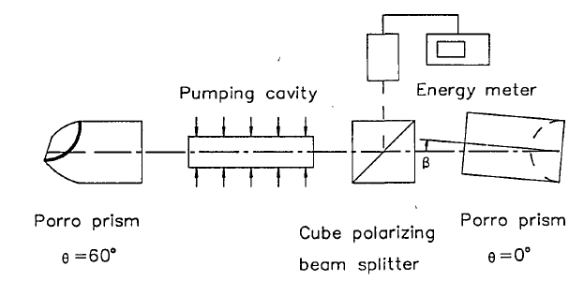
Fig.1 Laser model
The authors make no mention of displacement of the porro. It is my opinion that the oscillation axis is insensitive to displacement along the axis of the roofline and to a displacement along the optical axis. A displacement perpendicular to the roofline will cause some of the rays to fall outside of the active medium on their return path, thus diminishing the laser output. I feel that this warrants further investigation.

Axis of Oscillation

The key calculation of the authors is the derivation of the axis of oscillation. The ground work for this calculation is laid out in their December paper.² Their first paper¹ fails in that they incorrectly claim the oscillation axis lies on the line were the two planes defined by the apex of the prism and its normal intersect. The December paper correctly clarifies this line as one parallel that intersects the apex of both prims. Because the true oscillation axis is parallel to the model in the first paper, the authors calculation for deviations in beam pointing are still valid. These results are as follows:

$$η= -β$$

$$ξ=arcsin\left[\frac{cosθsinβ}{{(\cos^{2}{θsin}^{2}β+\sin^{2}{θcos}^{2}β)}^{1/2}}\right]$$

where η and ζ are the horizontal and vertical deviations of the output beam respectively.¹

In their September paper the authors show how a misaligned porro will affect energy output of the resonator. This paper references key calculations of the lateral distances of the misaligned oscillation axis from the optimal axis done in a “recent paper.”² Only two of the four equations are derived in the reference. These calculations represent the lateral displacement of the misaligned oscillation axis to the lasing medium axis at the prisms and both ends of the lasing medium. Of the four calculations only the maximum distance at the face of the medium is relevant. Given that L and L₂ are the length of the cavity and the distance to the face of the lasing medium with maximum displacement:

$$Δ=βcscθ{(L^{2}\cot^{2}θ+{L_{2}}^{2})}^{1/2}$$

Unfortunately this is one of the two missing equations. Its derivation is easily attainable utilizing the methodology used in the reference.

Assuming that the lasing medium is a rod of radius a, the authors propose that, “The laser output energy can then be regarded as proportional to the cross section of the mode volume in the same pumping conditions.” This in my opinion is a reasonable assumption. Given that Δ is the maximum distance of the misaligned oscillation axis, the cross-sectional area in the rod of the misaligned laser becomes (a-Δ)². A relation between the energy of an optimally aligned laser and a misaligned laser then becomes the ratio of the cross-sections.

$$\frac{E(β)}{E}=\frac{π{(a-Δ)}^{2}}{πa^{2}}$$

This however does not take into account the diffractive nature of the rod bending the misaligned oscillation axis closer to the axis of the optimally aligned laser. The authors account for this in a lengthy derivation from their December paper. (They reference “our previous paper” but the citation in the footnotes correctly references the as then yet to be published December paper.) The value of Δ corrected for diffraction is given as:

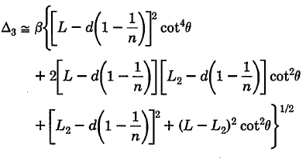

Experimental results

All three papers of the authors show excellent correlation of theoretical values to measured values. Of particular interest is the graph depicting experimental results to the theoretical values for energy with and without diffraction correction show here in Fig. 2.

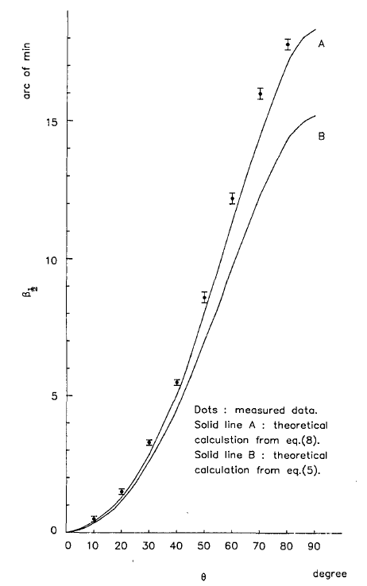
Fig. 2 Horizontal angular alignment tolerance vs. the prism azimuth angle.
Here we see graphically that as the azimuth of the porro approaches 90º the resonator becomes much more sensitive to yaw (horizontal) alignment.

One other note of interest in this paper was the device used to rotate the porro. The paper references an angular encoder built by Physik Instrumente Co. This remarkable device utilizes a piezo ultrasonic drive to control rotation to a resolution of 1 arc second. The reader is highly encouraged to follow the referenced link and watch the provided video under the CAD/Video tab.

Conclusion

Although the authors failed to address all degrees of motion of a misaligned porro, their efforts in addressing the degrees of rotation are complete and have sound experimental data to back up their results. I feel the scientific community could be better served by compiling these papers into one concise treaty on the influence of rotational misalignment.

Note that the ray tracing method is used instead of traditional field distribution and diffraction loss because of the lack of symmetry imposed by the porros. The experimental results of Lee and Leung agree well with theory so this does not appear to be an issue.
J. F. Lee and C. Y. Leung, "Beam Pointing Direction Changes in a Misaligned Porro Prism Resonator," Appl. Opt. 27, 2701-2707 (1988).
J. F. Lee and C. Y. Leung, " Lateral displacement of the mode axis in a misaligned Porro prism resonator," Appl. Opt. 28, 5278-5284 (1988).
M. K. Chun and E. A. Teppo, "Laser Resonator: Electrooptically Q-Switched Porro Prism Device," Appl. Opt. 15, 1942 (1976).
http://www.physikinstrumente.com/en/products/prdetail.php?sortnr=703070&

