Synopses of Technical Report
Eric Booen
OPTI 521

Paper Reviewed: David L. Platus, Negative Stiffness Mechanism Vibration Isolation System, Proc. of SPIE Vol. 1619, Vibration Control in Microelectronics, Optics, and Metrology, [1992].

- Introduction:

The author of this paper introduces the concept of a negative-stiffness mechanism (NSM) to replace existing isolations systems employing pneumatic or viscoelastic dampers. As such, the systems needed to be designed to resist micro-motion inputs, typical in most laboratory environments, while maintaining adjustability for changing system parameters and a compact design. Finally, the author suggests possible system configurations and provides transmissibility data for built and tested negative-stiffness mechanisms with transmissibility values of 1.2 and resonant frequencies as low as 0.4 Hz.

- Theory:

The basic concept for a NSM is to provide support to a payload with multiple springs (or components with spring constants) that can be balanced to provide isolation in a direction of interest. A simple example that the author used to illustrate this point is a hinged beam axially preloaded with a supporting spring used to balance the deflection caused by the axial preload (See Figure 1(a), (b) and (c)).
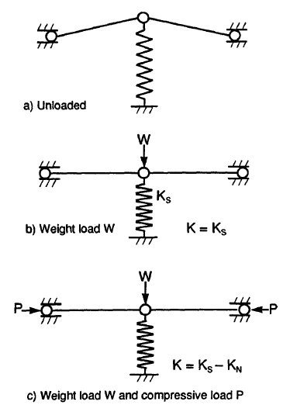
Figure 1: Schematic of NSM isolation system (Platus)

The system shown in Figure 1 displays a vertical isolation system in which the spring constant of the spring element can be taken as
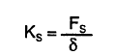

where K_{s} is the spring constant in units of pounds per inch and F_{s} is force required to deflect the spring, δ. Most spring manufacturers provide spring constants for a given spring size, however, custom springs can be ordered. The hinged beam, represented by the spring constant, K_{n}, is typically illustrated by the author as a flexure – a thin, compliant beam. For beams, the spring rate is determined by the modulus of elasticity, the cross sectional properties - including the area and the second moment of inertia – and the boundary conditions for the loaded end of the flexure. If the spring rate and the design of the beam are known, the spring rate for the system, K, is the difference between the spring rate for the spring and spring rate for the flexure. Depending on how many springs are needed for a given application needs, it can be expensive to order custom springs so the design of the flexure is typically modified to get your system spring rate.

Horizontal vibration isolation is achieved with the use of a vertical flexure preloaded close to its critical buckling load. By applying an axial load to a flexure while in the presence of a horizontal load, the flexure acts as its own NSM. This is achieved as the flexure has an axial stiffness complimented by its horizontal stiffness (See Figure 2).
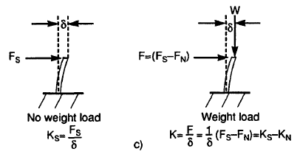
Figure 2: Vertical flexure used as NSM (Platus)

NSM systems used for horizontal isolation typically use opposing vertical flexures to compensate for increase in weight to a payload (See Figure 3). This works as the spring constant for the columns above the payload is positive while the spring constant below the payload is negative. Again, the positive and negative value for the spring constants can be illustrated by Figure 2. As shown, the weight is acting against the horizontal deflection of the beam as the weight compresses the flexure deflecting the payload vertically. The vector sum of the deflection in the horizontal direction as well as the vertical direction results in a total deflection as compared to the no weight load condition. When the weight is applied in the opposite direction, the opposite happens. Preload, Q, is used to tune the horizontal stiffness making the system resonant frequency adjustable.

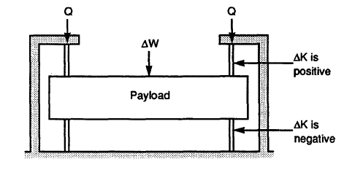
Figure 3: NSM system for horizontal vibration isolation. (Platus)

Although damping has not been discussed up to this point, the author puts a significant emphasis in the selection of viscoelastic dampers. If the systems were supported solely by spring elements, the transmissibility of the system at resonance would be very high. On the other hand, if damper elements were solely used to isolate a system, the system would have low transmissibility at resonance; however, there would be significantly more transmission at the higher frequencies. The ideal system has a combination of both spring and damper elements resulting in loss factors approaching, and possibly exceeding, 1.0. The loss factor is the ratio of the energy dissipated per cycle divided by the energy stored during the cycle. In a mass-spring-damper system this can be thought of as a critical damping ratio. Figure 4 illustrates the theoretical transmissibility curves that the author was attempting to achieve.

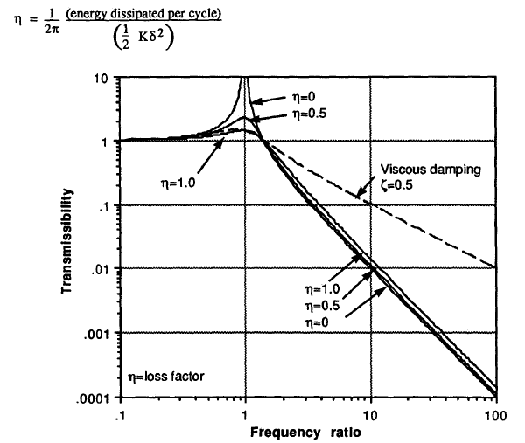
Figure 4: Theoretical transmissibility curves for NSM systems

- Results and Conclusion:

The author successfully built and tested an undamped and damped isolation system applying these concepts. Although optimum dampers were not selected for the tests, the author was able to achieve resonant transmissibility values of 1.2 at 0.8 Hz for damped systems and an undamped resonant frequency of 0.4 Hz. See Figures 10 through 15 of Reference 1 for the author’s tested transmissibility curves.

- Conclusion
The concepts presented in this technical report can be applied to any system that requires vibration isolation. As the author hinted at in the technical report, any optical system that is designed for use inside or outside of a lab usually requires hoses and ducts for heat transfer and electrical harnesses for power. By using negative-stiffness concepts, the stiffness of the interfaces between different components can be decreased, reducing the amount of vibration that is transmitted to an optical system. Of course, the amount of vibration isolation needed should be determined by a tolerance stack up and the merit functions of your system.

Another theme that the author attempted to present in this technical report is that spending the time to develop an adjustable NSM may be worth the trouble if vibration isolation is required and the weight of the system is going to change. Typically research and development projects are created to determine if a concept is even possible. Once the concept is tested and proved, the developer usually wants to increase the performance or add capabilities. If a NSM is required from the beginning of the project and is designed properly, accommodating for extra capability, increasing the weight of the system, should be no problem.

Lastly, knowledge or an addition technical report explaining the selection of damping materials and the design of damping components would be extremely beneficial to an engineer designing these systems. Although the author designed systems with low transmissibility at resonant frequency, it was always at the expense of off the shelf damping materials. According to the report different elastomers were used during the test until results were improved. If these were optimized prior to the test, even lower resonant frequencies as well as low transmissibility could have been achieved.

- References
- David L. Platus, Negative Stiffness Mechanism Vibration Isolation System, Proc. of SPIE Vol. 1619, Vibration Control in Microelectronics, Optics, and Metrology, [1992].

