Potting Optical Elements in Cells
Eric Booen
OPTI 521
12/07/08

Introduction

Potting optical elements into mechanical cells can ease the manufacturing process for most optical systems. Potting is defined as the process of filling in the space between an optic and its mount with a compliant material that offers resistance to shock, vibration and temperature change. Optical elements are typically potted into cells where flexure systems, springs or fasteners can not be used. Reasons for not using a mechanical joint can include high stress in the optical element, space limitations, or cost. However, an understanding of the requirements for the bond material and the sensitivity of the optic to the optical layout should be well understood before making the decision to use a bonded joint.
Potted optical assemblies usually consist of an optic that is axially constrained against three diamond turn surfaces. The optic is located to the center of the bore of the cell by using equally spaced shims made from compliant material. Once the optic is centered to the cell, adhesive is pumped through three equally spaced holes around the circumference of the cell. Tolerances on both the optical component and the cell need to be selected so that the adhesive does not get too thick, decreasing optical stability. Vukobratovich suggests a configuration for potting a lens in a cell seen in Figure 1.

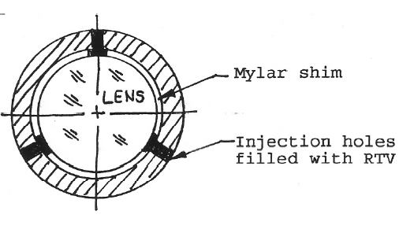
Figure 1: Sketch of optical element bonded into cell (from Vukobratovich)³

This paper is intended to present the relevant design issues which an opto-mechanical engineer must consider when designing a potted cell for an optical component. Common assembly practices and suggestions from the adhesive manufacturers will also be addressed.

Applications and Requirements

The first step in deciding to pot an optical element into a cell is understanding the system level requirements. These requirements are typically driven by the needs of the optical system and the environment that the optical system will be exposed to. Optical system requirements are usually determined through a sensitivity analysis based on a figure of merit for the system. Some common figures of merit include modulation transfer function, wavefront error, image size, strehl ratio, boresight (or line of sight error), and image motion. Typically, potted cells are used where optical sensitivity to line of sight and image motion requirements are low. This is due to the inherent instability of the bond material to changes in temperature (more in Materials section of this report).Types of optical components that fit into this category include filters, steering wedge pairs, and lenses with long focal lengths (to the first order). A quick calculation of image motion with respect to the motion of an optical element can be determined from the following calculation presented by Burge (See Reference 1).
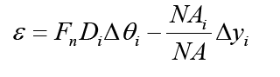
This equation shows that the image motion is directly related to the product of the f-number of an optical element, the diameter of the light going through the optic and the angular deviation of light leaving the element due to the position of the element. In short, small changes in position to the types of optics mentioned previously results in negligible changes in image motion.
The other requirements which tend to drive the design of potted cells are based on the environment that the cells are exposed to. Typically an operational temperature range and a storage temperature range are specified. If the temperature ranges are too extreme, the types of potting compounds that can be used are significantly reduced. Shock and vibration are other environmental factors that the design of a potted cell must address. Shock loads can fail a bonded joint by shear if the loads are high enough, while vibration loads can cause increased jitter (small image motion) depending on the stiffness of the bond joint.

Types of Potting Compounds

There are four common types of potting compounds that are used in opto-mechanics – epoxies, urethanes, acrylics, and silicone elastomers. Each material has its strengths and its weaknesses and there are many resources (including the manufacturers of the adhesives) that provide the mechanical properties of given elastomers at various temperatures. For the sake of this report, this section will be limited to describing each of the four adhesives common uses and some rules of thumb that can be used.
Epoxies are commonly used in environments with extreme temperature changes and high shock loads due to their high to moderate stiffness and strength. Epoxies are also low outgassing (as defined by NASA http://outgassing.nasa.gov) and have viscosities that are low enough making them easy to work with. Common brands include 3M Scotch Weld Epoxy Adhesive 2216, Mil-Bond A177B and Armstrong A-12. A rule of thumb for epoxies is to use 150ksi as the shear modulus and 2000 psi as the shear strength.
Urethanes are less common and can not be used at high temperature. Urethanes are typically used to locate optical components for short durations during the assembly process (staking).
The acrylics tend to be UV curing adhesives that can be bonded quickly with high strength. The most common UV curing acrylic is Norland NOA 61 which can also be used as an optical adhesive. However, it does not meet the NASA low outgassing requirements.
Silicone elastomer is typically found in the room-temperature vulcanizing (RTV) form. These adhesives have very high coefficients of thermal expansions and are typically not used as structural adhesives. If elastomers are to be used as structural adhesives they should be used in applications where the temperatures vary from 15 – 25°C and outgassing is not a problem. For elastomers, the shear modulus should be taken as 100 psi and the poisson’s ratio is about 0.5 (For more information about adhesives see References 3 and 4).
The mechanical properties for most adhesive should be readily available from the supplier of the adhesive. Adhesives should only be used in applications where the mechanical properties are known. In cases where specific mechanical properties are needed, the manufacturers of the adhesive can add certain materials to the adhesive to meet the requirements of the design.

Adhesive Failure

There are two types of adhesive failure that the opto-mechanical engineer should be concerned with – adhesive failure and cohesive failure. Adhesive failure results from critical damage along the interface between substrate and adhesive.² Adhesive failure usually results in lower strength bonds and can usually be improved with a well defined assembly procedure including a specified surface preparation and curing process. Information about the type of surface preparation is usually suggested by the manufacture of the adhesive and these surface preparations should be used in the absence of a tested procedure. The following is an excerpt from 3M Scotch-Weld Epoxy Adhesive 2216 B/A.

- Wipe free of dust with oil-free solvent such as acetone or alcohol solvent.
- Sandblast or abrade using clean fine grit abrasive (180 grit or finer)
- Wipe again with solvents to remove loose particles.
- If primer is used, it should be applied within 4 hours after surface preparation. If 3M Stock-Weld Structural Adhesive Primer EC-1945 B/A is used, apply a thin coating…
From 3M Scotch-Weld technical data sheet for Epoxy Adhesive 2216 B/A (March 2002)

An equally important process for reducing adhesive failure is the temperature, time and pressure required to cure the bond. Most manufacturers of adhesives provide this information in their technical data sheets and strength of the bonds are typically specified based on the cure cycle. Again, in the absence of test data, use the manufacturers suggested procedure. The surface preparation and cure cycle should be notified on an assembly drawing or a note on an assembly drawing should reference a document which specifies the proper bonding process.
If all measures are taken to ensure the integrity of the bond, then the expected failure mode for the bond should be cohesive failure. Cohesive failure results from critical damage to the bulk material of the bond.² This type of failure is usually caused by the stress developed in the bond (covered in the Design section of this document) Although, the cell should be designed such that no failure should occur the preferred mode of failure for a potted cell is cohesive failure. This ensures that the optic and mount are not damaged due to bond failure.

Design

The first step in the design of a potted cell is to determine the size and shape of the cell. As it is usually desirable to use off-the-shelf optics, a designer is usually stuck with common diameters and tolerances on those diameters that are easy to produce. If a custom optic is to be used in the cell, the designer should choose a tolerance on the diameter of the optic so that the cell diameter and tolerance can be made easily and to the gap tolerance required by the adhesive used in the assembly. As a general rule of thumb (supported by both Vukobratovich and Yoder), the gap tolerance for adhesives should be kept between .003” and .005” – there are some exceptions and these are presented in Table 3.26 of Reference 4. Lastly, the bond thickness should be symmetric about the optical axis and the thickness of the bond should be equal. These issues can typically be accounted for in the assembly procedure by using shims or spacer balls.
The next step in the design of a potted cell is to figure out the materials that are to be used in the subassembly. For optical components, the designer is usually stuck with optics are commercially available (usually BK7 or fused silica) or the material is selected due to system performance. In either case, the optical material typically has a coefficient of thermal expansion (CTE) that is smaller than the cell material. Table 1 presents a table of common optical materials and their CTE’s. (For more information on optical materials and their mechanical properties, see References 3 and 4).

Table 1: Common optical materials and some selected material properties
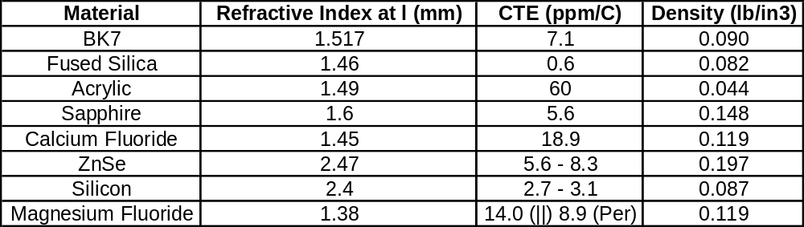

To keep the price of the sub-assembly low, the cell material is usually made from common metal materials that are easily to machine. Aluminum 6061-T6 is one of the easiest materials to machine; however, it has one of the highest CTE’s. Other metals that are commonly used in potted cell designs are stainless steel and titanium as the specific stiffness (ratio of Young’s Modulus to density) is high and their CTE is low (closer to the CTE of the glass). Use of the more exotic materials must be justified through proper analysis. Table 2 presents some of the more common metals used in opto-mechanics and some of their mechanical properties. (For more information on metals and their mechanical properties, see References 3 and 4).

Table 2: Common metals and select material properties
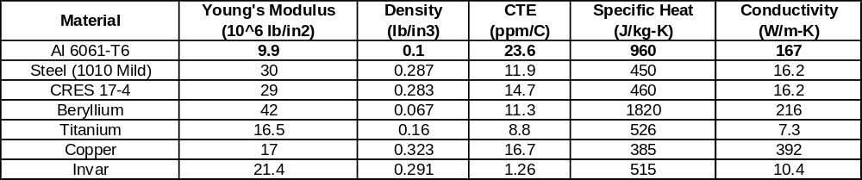
This difference in the CTE between the optical material and the cell material presents a problem as the temperature of the cell is increased or decreased from its zero stress state. As stated in the Adhesive Failure portion of this document, adhesives are commonly cured at elevated temperature to decrease the chances of adhesive failure. While curing at the elevated temperature, the adhesive bonds cures in the gap defined by the elevated temperature of the cell material and the optical materials. So the reference temperature for the state where there is no stress in the bond due to temperature is the cure temperature. For example, Scotch-Weld 2216 is recommended to cure at 66°C, so, after the cell is cured and the cell is introduced to a lab environment of 20-25°C, shear stress will be present in the bond.
The shear stress develops in the bond line as the metal cell grows or shrinks faster than the optical material. The difference in thermal growth is exaggerated in Figure 2.

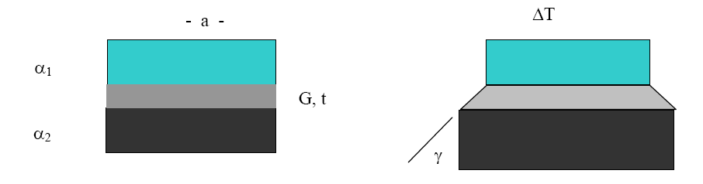
Figure 2: Diagram of shearing stress present in the bond line for a potted cell (Burge)⁵

If the diameter of the bore of the cell (D) is assumed to be large when compared to the bonded area (a), the following expression for the shear stress can be used for a back of the envelop calculation.
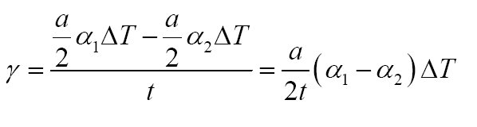
In this case, a is the diameter of the bond material and t is the thickness (or gap) of the cell. The shearing strain and the shear modulus of the material can be used to compute the shear stress in the bond line due to temperature change from the zero stress state.
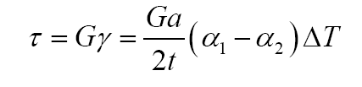
If the compliance of the cell and optic are to be taken into account with respect to the compliance of the adhesive, Vukobratovich supplies the following equation:

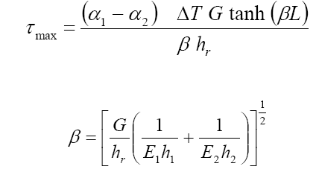
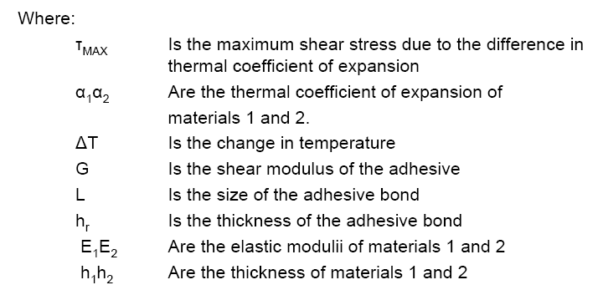
(From Vukobratovich, Reference 3)

The shear stress is compared to the shear strength (typically around 2000 psi for epoxies) to evaluate whether the bond failed. If the shear stress is exceeds or is too close to the shear strength, one of the following steps (from Burge) should be followed:
- Use an epoxy with lower modulus as temperature⁵
- Use thicker adhesive layer⁵
- Prepare the glass surface to provide higher shear strength⁵
- Use smaller bond area⁵
- Use flexures that allow for thermal expansion⁵

It should be noted, that increasing the adhesive layer thickness is not always recommended (See Table 3.26 of Reference 4).

Using a smaller bond area should also be used with caution as shock survivability may become a problem. Another failure of bonded joints is due to a bond shearing when subject to a shock load. The requirements of the cell should indicate a shock load that the cell must survive. The shear stress that develops in a bonded joint can be represented by the following equation:
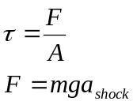

In this equation, A is the area of the bond (for a cell using three equally spaced bond joints it is the total area of all three bonds) and F is the mass of the optical component (m) multiplied by gravity and an acceleration factor (a_{shock}). Again if the shear stress exceeds the shear strength the design must be changed.
If the design of the bond meets the requirements of the system and survives this preliminary analysis, a more sophisticated model for the cell should be created and shown to survive the environmental requirements. A check on the wavefront error caused to the optic through mount can also be quantified with a finite element model. Testing of the cell should also be completed prior to finalizing the design to check for actual line of sight and image motion errors. Typically this is done with an interferometer or a stable laser with a high precision CCD array.

References
- J. H. Burge, “An Easy Way to Relate Optical Element Motion to System Pointing Stability,” Proc. SPIE 6288 (2006).
- Blain Olbert, “Adhesive Selection and Characterization – What you don’t know can kill you,” USAO Engineering Seminar (Aug 2004).
- Daniel Vukobratovich, “Introduction to Opto-Mechanical Design,” Notes, (2008).
- Paul R. Yoder, Opto-Mechanical Systems Design, 3rd, CRC Press (2006).
- J. H. Burge, “Adhesives” Class Notes for OPTI 521, University of Arizona.

