Steve Hearon
OPTI521, Project #1
Review of a Journal Article
November 7, 2009

1. Introduction
This report is a review of the journal article listed as Ref.[1], which was presented at a conference on space mechanisms in 1995[1]. The work, funded by the European Space Agency (ESA), was for the development of an opto-mechanical design for a long-stroke interferometer arm to be used for space-based interferometer missions.
The concept driving this work was an interferometric system consisting of several telescopes that together would synthesize a large, sparse aperture (Figure 1, from Ref[1]). The work was initiated and funded within the Optical Aperture Synthesis Technologies (OAST) program, whose charter is the development of key technologies for space interferometry. In each arm a delay line would be introduced to compensate for path length variations. The entire structure would be lightweight for ease in insertion into earth orbit. This lightweight structure would experience flexure and distortion due to acceleration and thermal stresses, which are compensated by the delay lines. An active path stabilization system maintains the arm lengths to a fraction of a wavelength. (The means by which the differential path lengths would be measured and controlled was not discussed in this work.)
The achieved stability in terms of lateral deviation is a few microns, factoring in in-flight stresses and thermal excursions.
The mechanical design reported here could also be applied to a Fourier Transform Spectrometer system, which employs a Michelson interferometer with a scanning mirror.
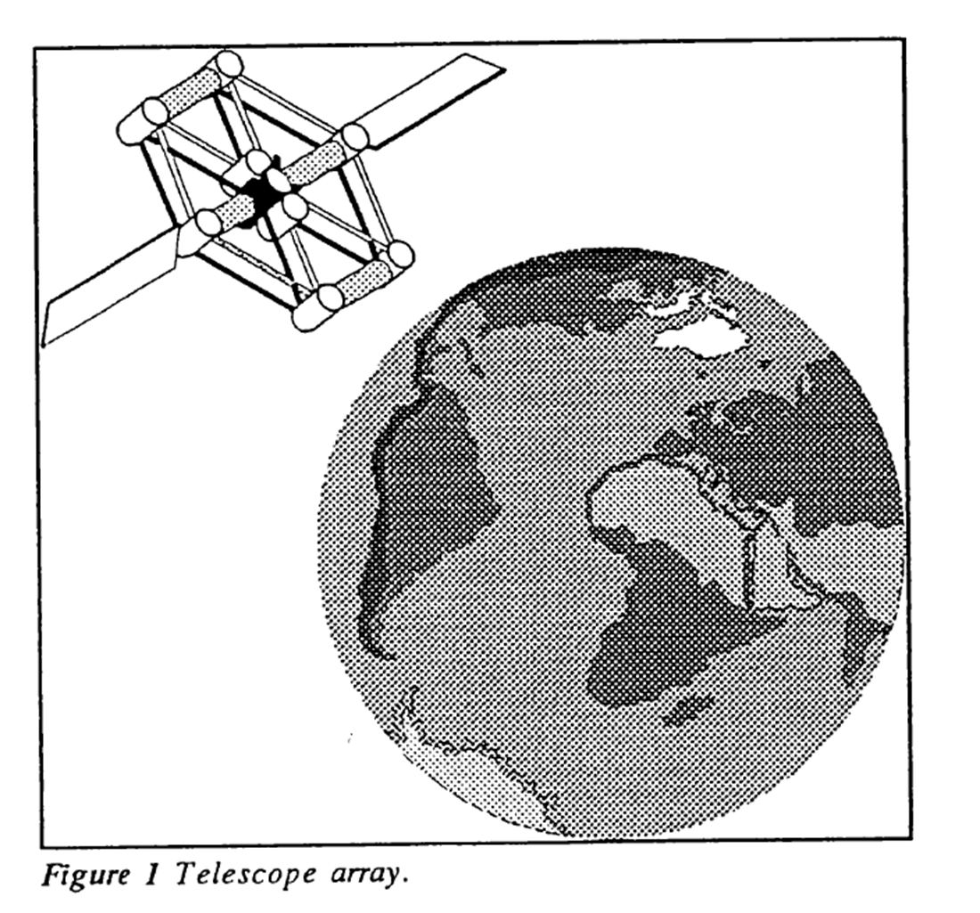

2. Optical and Mechanical Considerations
The optical delay line requirements are that no significant wavefront errors, beam tilt, or decenter may be introduced. This was achieved by using a “cat’s eye” retroreflector telescope, which consists of a parabolic primary mirror and a flat secondary mirror in the focal plane of the primary (Figure 2, from [1]). The primary mirror has a focal length of 100mm. Light beam diameter at entrance and exit is 10mm. The beam is focused on the secondary mirror.
The delay line has two stages for path length adjustment. The entire cat’s eye unit is moved using a linear induction motor over a stroke of 50mm, inducing a 100mm total path length coarse adjustment. Additionally, the secondary mirror has a piezo actuator with a stroke of +10 microns for fast, quick-response, fine control of the path. (10 microns was determined to be a stroke that would not introduce disturbances in the optical performance of the retroreflector.) The optical baseline was determined to be about 100 meters, in a flexible structure, to accommodate a low-mass payload. A max slew speed of 0.05mm/sec is desired. Mechanical requirements for the delay line are outlined in Table 1.
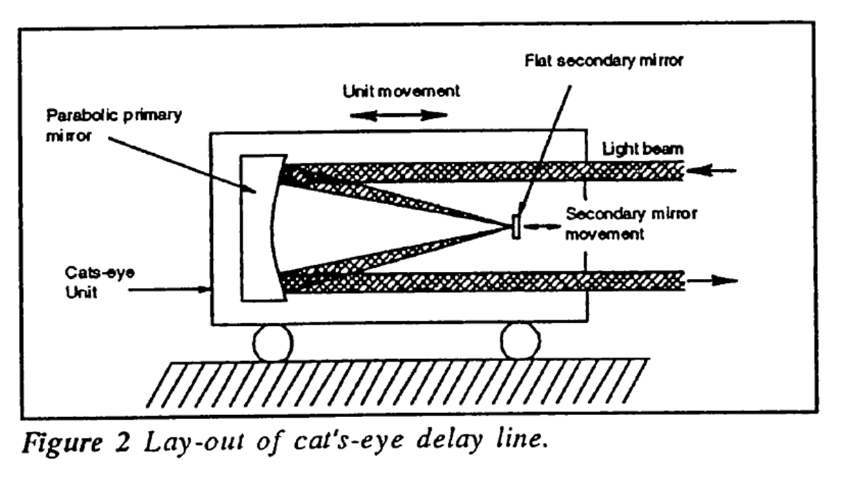
Table 1 Mechanical Requirements
Parameter | Value
Stroke | 50mm
Maximum Speed | 0.05mm/sec
Path Compensation Accuracy, RMS | <10 nm
Response Time | < 3 ms
Decenter | <5.5 microns
Tilt | < 55 urad

3. A Traditional Kinematic Slide Solution for a Long-Stroke Delay Line
A statically determined optical relay line solution is preferred, due to the stringent requirement on lateral displacement. A traditional example of such a solution is a kinematic slide, developed in [2], discussed in [1], and shown in Figure 3 (from Ref[1]).
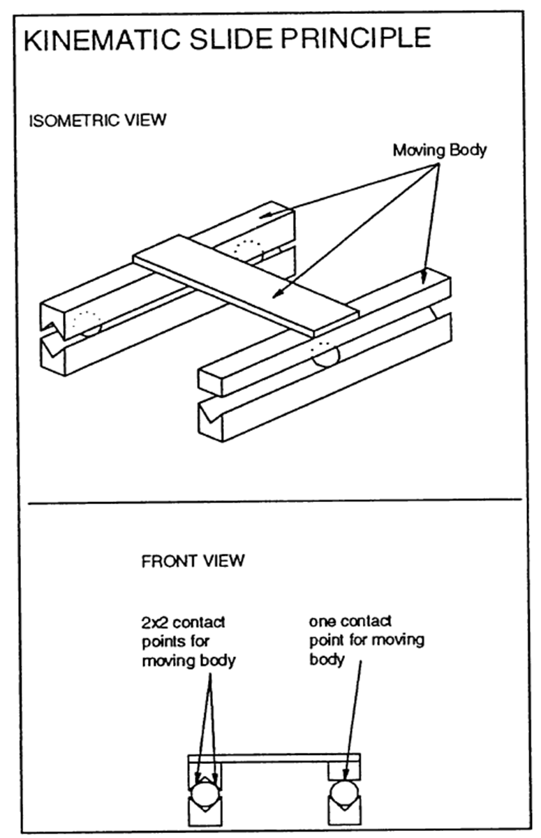
Figure 3 Kinematic Slide Concept (from [1])

The kinematic slide is constrained using 5 contact points with 3 ball bearings (Figure 3); thus the system is well-constrained but not over-constrained. Thus, changes in temperature will not cause stress or deformation of the structure. For earth application gravity provides the required pre-load. However, disadvantages for this space application include:
- Temperature changes cause a lateral displacement with respect to desired motion;
- Pre-load is necessary to deal with zero-gravity space environment, resulting in possible reduced bearing life.

4. Rotationally Symmetric Kinematic Six-Ball Guide System
The interferometric delay line design presented in the reviewed paper attempts to overcome the limitiations of the kinematic slide. The delay line design is shown in cross-section in Figure 4.
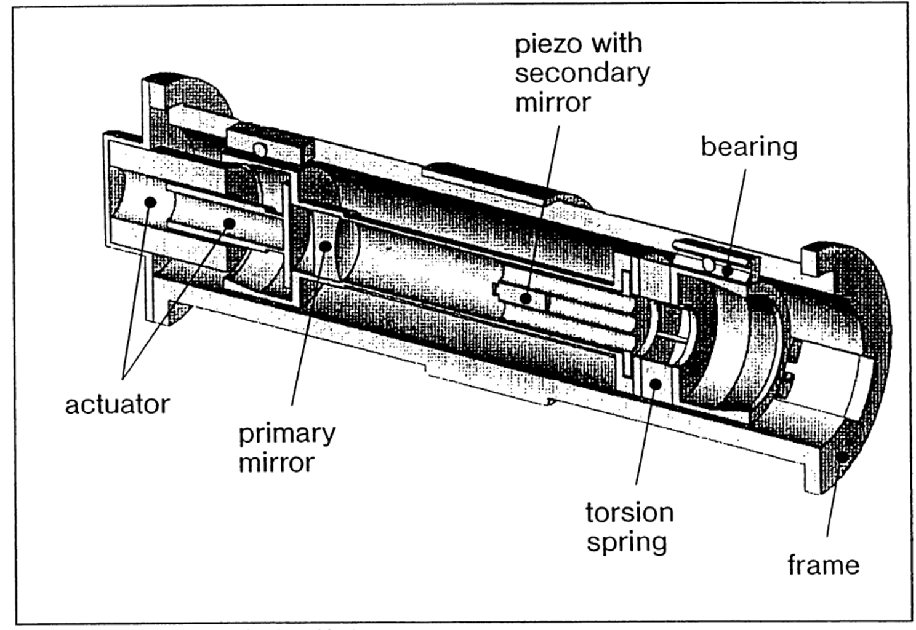
Figure 4 Delay Line Design, Cross-Section, Indicating Components (from [1])

The design consists of two concentric cylindrical components. The inner cylinder contains the retro-reflector telescope, and moves with respect to the fixed outer cylinder on 6 ball bearings, each of which experiences one contact point against the frame and the moving telescope. The kinematic system, for which 5 of the 6 degrees of freedom are fixed, thus has one over-constraint. A rotational pre-load is applied via the torsion spring indicated in Figure 4. A linear motor actuator provides the coarse control of the path length.
Figure 5 depicts the rotational symmetry concept. The retro-reflector body is concentric with the frame: its center of mass and thermal center coincide with the center of the frame. The torsional spring causes rotation of the body against fixed supports of the frame, securing the retroreflector but allowing motion along the track. With temperature changes, there is no lateral displacement due to the rotationally symmetric design.
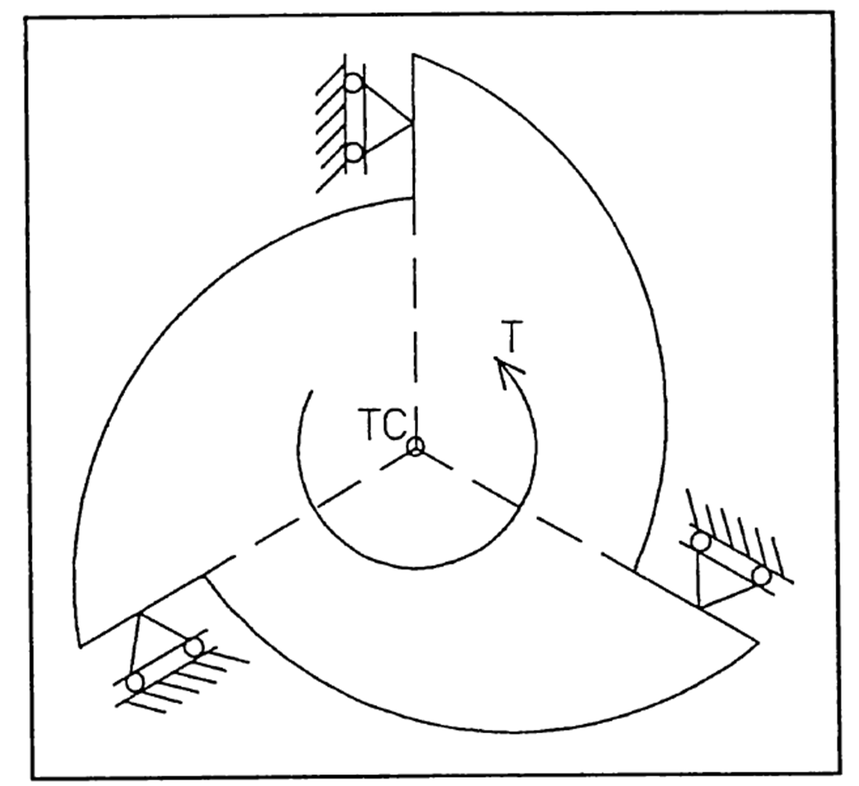
Figure 5 “Rotationally Symmetric” Kinematic Design, Showing Center of Mass / Thermal Center (TC) and torque direction (T) (from [1]

The bearing configuration is depicted in Figure 6 (from [1]). Each ball runs between a V groove and a flat surface. The V-groove and flat surface contacts accommodate thermal expansion without introducing distortions. The Hertz contact pressure is approximately given by $σ_{C}={\left(\frac{E^{2}F}{R^{2}}\right)}^{1/3}$
where E is Young’s modulus, F is the force, R is the ball radius. The applied force must be adequate to overcome any accelerations due to micro-gravity in the spacecraft. From the equation, large ball bearings are desirable for low contact stress. The ball bearings used here are 8mm in diameter, which, according to the authors of the study, ensures long life.
The authors claim that, based on a previous study [3], creep is not an issue with kinematic slides based on large balls.
5. Conclusions
The design reviewed here appears to overcome the limitations associated with the traditional kinematic slide.
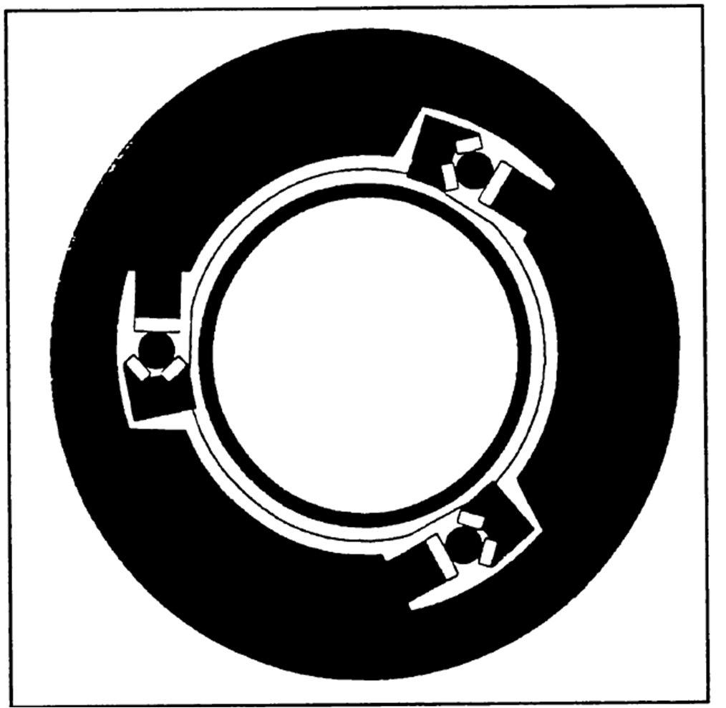
Figure 6 Bearing Configuration for the Kinematic Design (from [1])

References
[1] Braam, van Mierlo, Snijders “Kinematic Six-Ball Guide for Long Stroke Optical Delay Line “, Proc. Sixth European Space Mechanisms & Tribology Symposium, Technopark, Zurick, Switzerland, 4-6 October 1995.
[2] Furse, “Kinematic design of fine mechanisms in instruments”, J. Phys.E: Sci. Instruments, Vol 14, 1981.
[3] Thome et al, “A Fourier transform spectrometer for vacuum ultrasonic design and performance”, J Phys E: Sci. Instrument, vol 20, 1987

