Birefringence Precision Measurement and Reduction Tutorial

Darren Miller
Opti 521
12/07/07

High precision optical instruments used in industrial applications require control of many variables in order to maintain precise measurements. All of the optical components in a precision system must be controlled. One of the most important parameters to control in many applications is residual linear birefringence due to a gamut of sources. An engineer must know how to measure the birefringence and techniques to use to reduce it, if it is seen as a large source of error, which it is for many precision applications. High-speed, high sensitivity and repeatable systems for measuring birefringence are used in precision applications. Applications such as lithography use the highest quality materials in the industry, and therefore need to be able to characterize the materials as completely as possible. A technique used for precision polarization measurements is to use PEMs (photo-elastic modulators) in concert with lock-in amplifiers. A system is produced by Hinds instruments, Inc. that uses this technique, the ExicorTM. Once the birefringence is measured methods of reducing it are useful to know. Birefringence reduction after the element is fabricated is difficult to accomplish, but it has been shown that annealing can accomplish it to some degree². It is easier to reduce the birefringence of a material during the fabrication step³. Plasticizing polymers using compressed gasses can achieve reduction in stress, and therefore reduce birefringence.

For course measurements, engineers can generally place the element to be measured between crossed polarizers, and rotate the element to study the changes in the illuminated sample. Just by using a trained eye, an engineer can easily determine angle and magnitude of birefringence in a sample down to a quarter-wave or better. This technique is time consuming and does not give the sensitivity required for precision optical systems. A very accurate, very efficient technique to measure the birefringence (stress, thermal, etc.) of optical samples is through the use of photo-elastic modulators which can operate at speeds greater than 50k Hz. Baoliang Wang of Hinds Instruments, Inc. has developed a system that performs linear birefringence measurements at high speed and high accuracy.

Wang’s method involves the use of two photo-elastic modulators at different frequencies and a single detector. A polarization generator of known orientation (45°) is followed by the first PEM oriented with its fast axis at 0°, which is followed by the optical sample. After the optical sample is a second PEM oriented at 45° and then a polarization analyzer at 0°. This system coupled with a detector modulates the polarization state incident on the sample and exiting the sample in such a way that high speed and high accuracy measurements are easy to accomplish with lock-in amplifiers. The following figure displays a block diagram of the optical and electrical layout of this system¹.
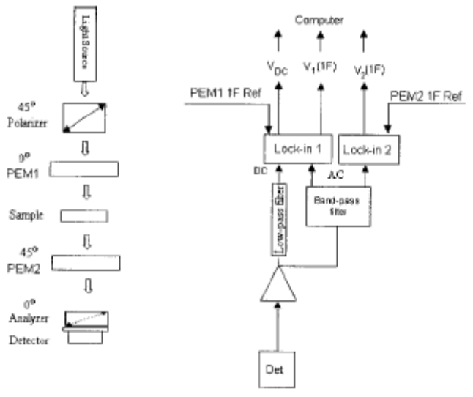
Figure 1 – Dual PEM birefringence measurement system diagram.¹

The lock-in amplifiers receive the AC signals from the detector which corresponds to the fundamental frequency of each of the PEMs. These signals coupled with the DC signal are processed to give the retardance magnitude and angle of the fast axis. Using Mueller calculus, the light intensity reaching the detector is given as¹:

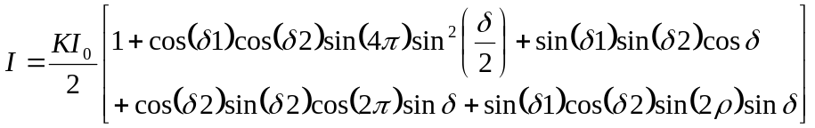 (1)

where I₀ is the intensity incident on the first polarizer, K is a transmission coefficient given by the first polarizer; 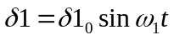, 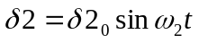, where ω₁ and ω₂ are the modulating frequencies of the PEMs and δ1₀ and δ2₀ are the magnitude of the modulating retardance given by the PEMs. Most importantly, δ is the magnitude of the retardance of the optical sample, and ρ is the orientation of the fast axis of the optical sample. The lock-in amplifiers measure a voltage at the first harmonic frequency of each of the PEMs that correspond to the output of the system at that frequency. After a bit of math, the output of each amplifier can be rearrange to give:

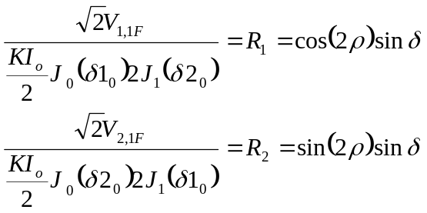 (2)

Solving for the desired parameters:

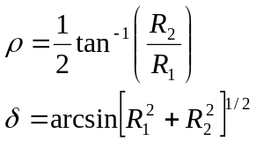 (3)

For a system of this kind, the systematic errors have been shown to be less than 0.005nm⁴. The accuracy, speed, and resolution of this type of birefringence measurement system makes it a prime candidate for many applications. This system is used in an industrial environment to measure the birefringence of CaF₂ windows used in microlighography, PEM optical elements, compact disc blanks, low retardation wave-plates, and photomask blanks. The following figures demonstrate the output for measurements made with the dual PEM birefringence measurement system known as ExicorTM.
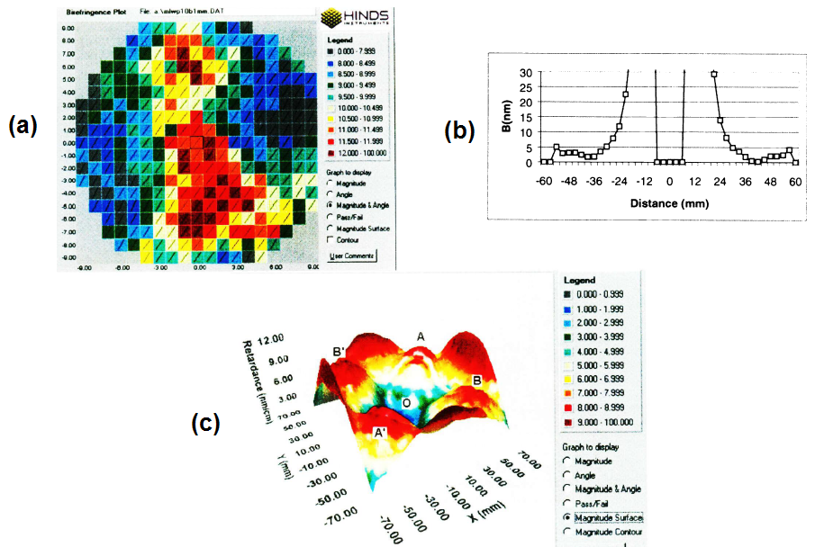
Figure 2 – Results from the Exicor system for (a) Low retardation retarder, (b) A compact disk blank, (c) a fused silica window. ⁴

Once the birefringence is measured for a certain sample there are three actions an engineer can take: discard the use the sample, discard the sample, or attempt to reduce the birefringence of the sample at a certain stage of development.

An engineer can reduce the birefringence pre-processing or post-processing. A novel approach used to reduce the stress-induced birefringence in polymers is to plastize the polymer using a compressed gas. This reduces the glass transition temperature which decreases the stress relaxation time so that treatments can be used to greatly reduce stress. The stress generated in polymers due to relaxation is given³:

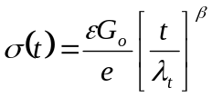 (4)
where
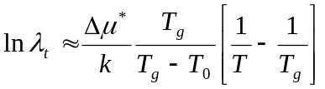 (5)

where G₀ is the modulus, t is the time in seconds, λ_{t} is the characteristic relaxation time, β is the Kohlrausch-Williams-Watts parameter, which is about 0.5 for polymers, Δu* is the activation energy for rotation relaxation of one conformer without cooperativity at T₀ = 0K, T_{g} is the glass transition temperature, and k is the Boltzmann constant. Under specific CO₂ gas pressures sol-gel, acrylic and epoxy were treated to reduce the stress of the polymer. Birefringence in these polymers is generally caused by the CTE mismatches of the material and the chemical shrinkage. Estimations of the birefringence caused by these parameters are given in the following table³.

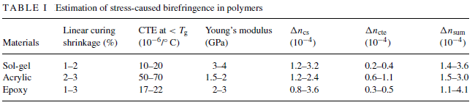

The reduction of the birefringence in each of the polymers under these treatment conditions is given in the following table³:

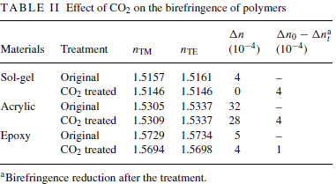

The advantage of this technique is that it can be accomplished at low temperatures with controllable processing times. With its compatibility with polymers, CO₂ is an efficient gas to use to reduce stress in the polymer and is safe to release into the environment.

Reduction in residual birefringence of an optical sample can also be performed after the component has been fabricated. Annealing performed on aspheric glass lenses has been shown to reduce stress and therefore birefringence by up to a factor of five². Using a Mueller matrix polarimeter, J. Wolfe and R. Chipman studied the affect of annealing on coated aspheric lenses with radial stress patterns. The retardance and orientation of a lens sample before annealing is given in the following figure:

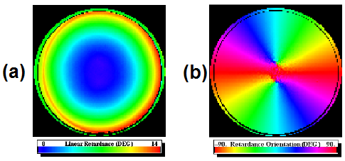
Figure 3 – (a) Linear retardance magnitude of an AR coated aspheric lens. (b) Retardance orientation of an AR coated aspheric lens.

After being baked at 400ºC for 6 hours, the retardance magnitude changed dramatically. The following figure demonstrates this change.
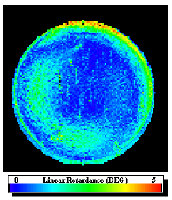
Figure 4 – Linear retardance magnitude of an AR coated aspheric lens after annealing.

This annealing process was destructive, however. Those lenses that were not mounted in metal mounting rings cracked during the cooling process. The authors hypothesize that the mounted lenses dissipated the heat readily into the metal mounting rings that served as a buffer in the cooling process, while the unmounted lenses experienced thermal stresses greater than the failure mode levels, causing crack propagation in the glass.
The state of modern optical engineering is such that precision measurements are needed to be made on a regular basis. At these levels of precision, polarization effects are primary concerns for many systems. Being able to quickly and accurately determine birefringence of optical samples as well as being able to reduce this birefringence is of great importance. The dual PEM system (Exicor) is used in important industrial environments to measure birefringence in such a way. Plastizing and annealing of optical materials have been shown to reduce the birefringence by reducing the stress of said materials^{2,3}.

References:

- B. Wang, “Linear birefringence measurement instrument using two photoelastic modulators,” Opt. Eng. 41(5), 981-987 (May 2002)
- J. Wolfe and R. A. Chipman, “Reducing symmetric polarization aberrations in a lens by annealing,” Opt. Exp. 12(15), 3443-3451 (July 2004)
- Z. Zhang, I. Liu, G. Xiao and C.P. Grover, “Novel approach to reducing stress-caused birefringence in polymers,” Journal of Materials Science 39, 1415-1417 (2004)
- B. Wang, T.C. Oakberg and P. Kadlec, “Industrial applications of a high-sensitivity linear birefringence measurement system,” SPIE Vol. 3754, (July 1999)

