Precision Linear Motorized Stages
Tutorial Paper
(Presented in class on 12/5/06)

Proteep Mallik
12/6/06

Abstract
For precision motion control for opto-mechanical systems, it is ideal to use precision motorized stages. This report is concerned with precision linear motorized stages from Parker Motion that have a long range of travel (about 2-meters), have a resolution of ~1μm and are driven by stepper motors. A comparison of different types of stages from different vendors is also shown.

Specs of Some Stages

 | Aerotech |  | Parker |  | Velmex
Model | ALS5000 | ABL2000 | 400ST | 406XR | XSlide | BiSlide
Motor Type | Servo | Servo | Stepper | Stepper | Stepper | Stepper
Total Travel | 1m | 1.2m | 1.5m | 2m | 0.8m | 2m
Resolution | 0.001μm | 0.06nm | (not given) |  | (not given) | 6μm
Repeatability | 0.5μm | 0.4μm | 0.1nm | 1.3μm | 2.5μm | 4μm
Max Load | 135kg | 50kg | 1000kg | 630kg | 16kg | 150kg
Cost | $15,000 | $25,000 | $2000 | $5000 | $800 | $1800
Image | 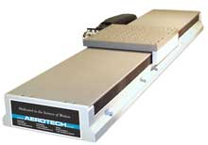 | 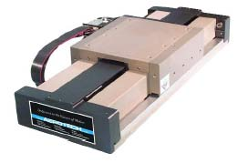 | 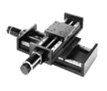 | 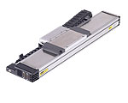 | 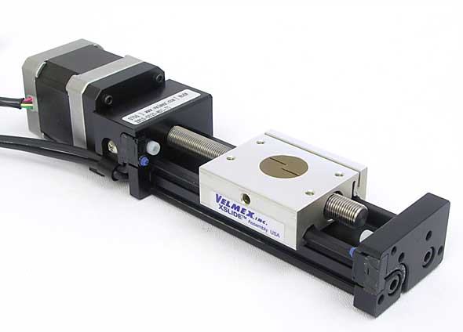 | 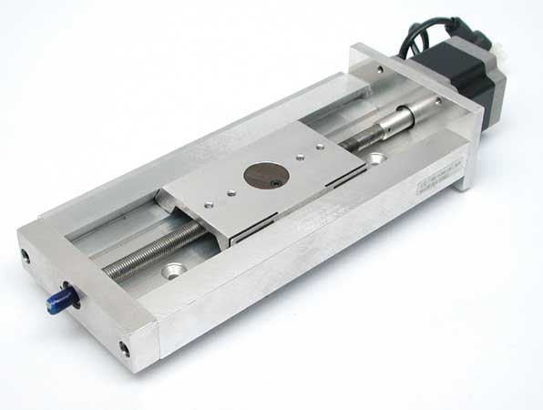
Table 1: Summary of specifications of some precision linear stages

A summary of 6 different precision linear stages is given above as a quick reference for the end user.

Introduction
Motion control in opto-mechanics involves the precise positioning of optics and mechanics. This is best achieved, nowadays, with motorized stages. These stages have travel ranges from a few microns (flexures) to several meters (servo- or stepper-driven). I am particularly interested in large optics and therefore I will limit myself here to only long travel range stages. I’ll specifically describe some of the systems available from Parker Motion (www.parkermotion.com). This paper is divided into the following sections: 1. Motion Control and some applications of such stages, 2. System Components, where I’ll describe the 3 components that go into these stages- the stage itself, the motor (servo vs stepper) and the controller/computer, 3. Examples of some vendors and stages available, 4. Parker Motion stages in particular, 5. Stages used in a null test setup, and finally, 6. Conclusions and, 7. References.

1. Motion Control
The precise motion of mechanics and optics is necessary for many opto-mechanical applications. Motorized and automated control is essential for performance. Motion control is used in many applications such as wafer testing, lithography, printing, patterning, laser machining and welding, robotics and numerous optics applications.
Motorized motion control has many applications over manual control. Motorized control is more precise, smooth and repeatable. Motorized control is essential for automation. Also, it is easier to move heavy parts and manage complex systems using motors. Finally, it requires less manpower.

2. System Components

2.1. Overall System:
Every motorized linear stage comprises 3 essential components- a stage, a motor and a controller.
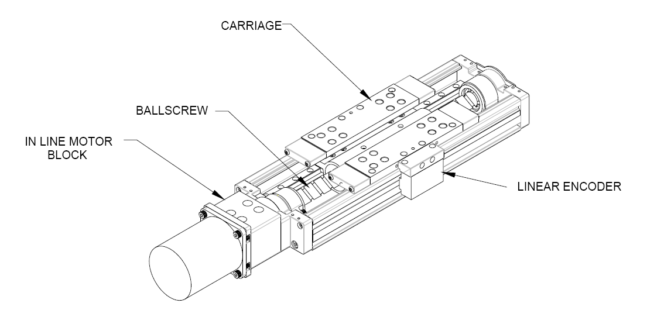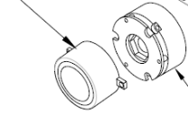
ROTARY BRAKE
SHAFT BRAKE
Figure 1: Overall system for a linear motorized stage.

The linear stage has a carriage, whose motion is recorded by a linear encoder. The carriage is moved by a ball screw which is driven by a motor. The motor might either be a stepper motor or a servo motor. A comparison between the two is given later. The motor might have a rotary encoder to give feedback about motor position. The stage often also has limit and home switches which give feedback regarding when the end of travel is reached. The motor also has a brake to stop it when necessary, and the shaft or the screw may also have a brake for a similar function.

2.2 The Stage:
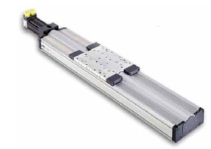
The stages we are interested in here are long range ones, with a travel of 2m or so. These stages have a repeatability of 1nm rms or better, and their precision is also in the range of a few nm. These stages are also very stiff, mostly made of extruded Al with a steel screw. For better stiffness and performance these stages should be mounted on large, flat surfaces. The application of the stage determines the type of motor requirements needed, i.e. torque and efficiency.
The typical cost of such a stage is $5000. Most of these stages are very convenient to use with convenient locations for cable hookups and computer control.

Figure 2: A typical stage: this one is from Parker Motion.

2.3. Motor: Servo vs Stepper:
The motor is what drives the carriage on the stage. There are two common types of motors used- servo and stepper.

2.3.1. Servo Motors
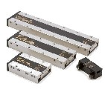
There are 3 kinds of servo motors- ironcore, ironless and slotless. The differences are based on the type of coil and magnet arrangement inside the motor. Slotless motors are typically the most accurate and high performance. The typical repeatability of such motors is 1nm and the resolution is 0.1nm. Servo motors need linear position encoders and can carry heavy loads with very smooth and fast motion. They run on either AC or DC power and cost about $5000.
Figure 3: Servo motors from Parker Motion

2.3.2. Stepper Motors
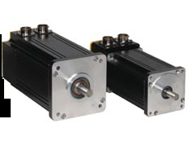
Stepper motors are driven by multi-pole motors. Each pole is a large step of rotation for the motor. However, depending on the motor encoder, each such step can have 2^{N} steps where N is the number of bits in the encoder. For example, an 8 bit encoder means that there are 256 steps per pole. For an 8 pole motor one revolution of the motor is divided into 2048 steps or 5.7 steps/degree. That’s the motor resolution. Because of this the motor has an inbuilt position feedback, and stages driven by stepper motors do not require linear encoders for position feedback. However, due to slippage and step errors, most stepper driven stages do have encoders.
Figure 4: Stepper motors from Parker.
The repeatability of these motors is about 10nm rms and the resolution is 1nm at best. These motors are cheaper than servo motors and are easier to maintain.

2.4. Controllers:
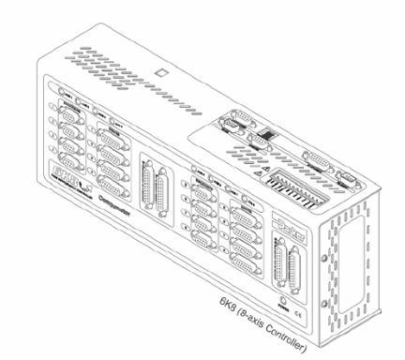
Controllers are units that interface the user to the linear stage. They have computer interfaces and interfaces to the motor of the stage. The controller can also be remotely operated. The controller has inputs for the stage encoders, limit switches apart from computer controls. Most controllers are also programmable by downloading and instruction set onto them. A common programming platform for many controllers is ActiveX which is user friendly.
Figure 5: The 8-axis stepper motor controller from Parker.

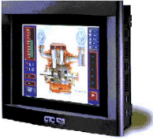
Some very user friendly computers with touch screen monitors are available to program and control these linear stages. The computer communicates with the controllers via either RS-232 or Ethernet interface. Computers and monitors for industrial applications are also available, and these are rugged and suited for harsh environments.
Figure 6: A touchscreen monitor and computer unit from CTC (Parker).

3. Vendors
Apart from Parker Motion (also known as Daedal Positioning, Compumotor and Parker Hannifin) there are several other manufacturers of linear stages. Some of these are Velmex Inc., Aerotech Corp., and Newmark. Some of these stages are compared with each other in the following table.
Image
$1800
$800
$5000
$2000
$25,000
$15,000
Cost
150kg
16kg
630kg
1000kg
50kg
135kg
Max Load
4μm
2.5μm
1.3μm
0.1nm
0.4μm
0.5μm
Repeatability
6μm
(not given)
(not given)
0.06nm
0.001μm
Resolution
2m
0.8m
2m
1.5m
1.2m
1m
Total Travel
BiSlide
XSlide
406XR
400ST
ABL2000
ALS5000
Velmex
(stepper)
Parker
(stepper)
Aerotech
(servo)
Table 2: Comparison of linear motorized stages from 3 manufacturers.

4. Parker Motion Stages

Parker has a wide array of linear motorized stages with high precision.

 | 400ST Square Rail Sliders | 406XR Series Sliders
Drive and Motor | Screw with stepper motor | Linear bearing, ballscrew & motor
Total Travel | 1.5m | 2m
Max acceleration | 20m/s² | 20m/s²
Repeatability | 0.1nm | 1.3μm
Maximum Load | 1000kg | 630kg
Stage Weight | 25kg | 2.7kg
Size | 2m X 0.2m X 0.12m | 2.3m X 0.15m X 0.05m
Cost | $2000 | Up to $5000
Table 3: Comparison between 2 different Parker linear motorized stages.
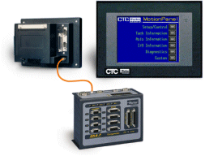
The Parker stages are controlled via the 6K series stepper motor controllers, which are connected to a computer via Ethernet communication. The computer and touchscreen monitor are a unit rated for use in industrial environments. The controllers can be used as either servers of clients and several of them can by piggy-backed together to control more than 8 stages at one time. The stages can, furthermore, be attached together to get motion in several directions, and an example is shown in the next section.
Figure 7: Parker control suite with controller and computer with touchscreen monitor, all rated for industrial environments.

Primary Mirror
CGH
Null lens
5. Null Test System
The stages described above have found good use in a null test system that I have built at the Optical Sciences Center. This system has a fully automated motion control system with 7 stages- 5 linear and 2 rotation. We are interested with the 5 linear stages here. These are controlled via a 6K8, 8-axis controller and computer with touch screen monitor suited for industrial environments.
This system is designed to test a computer-generated hologram which mimics a 1.87m off-axis parabola. This hologram is then used to test a null lens which will be finally used to test the real parabolic mirror. This test requires very careful calibration and precision control. The motorized control in the system is designed to achieve this high performance.
Figure 8: Null test schematic.

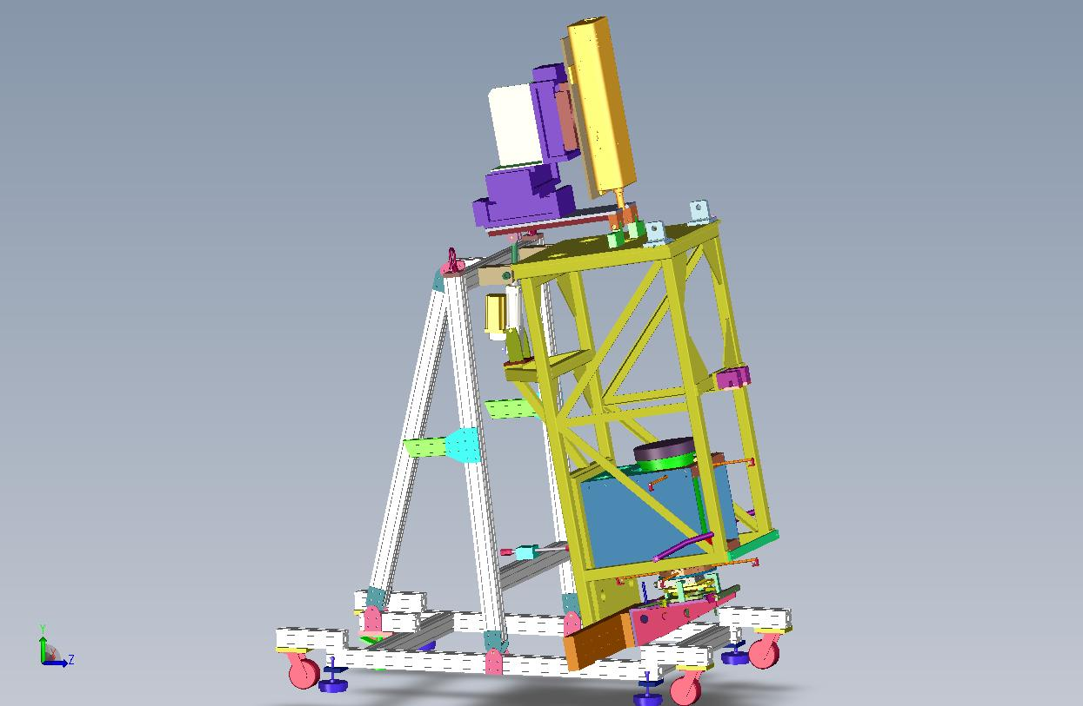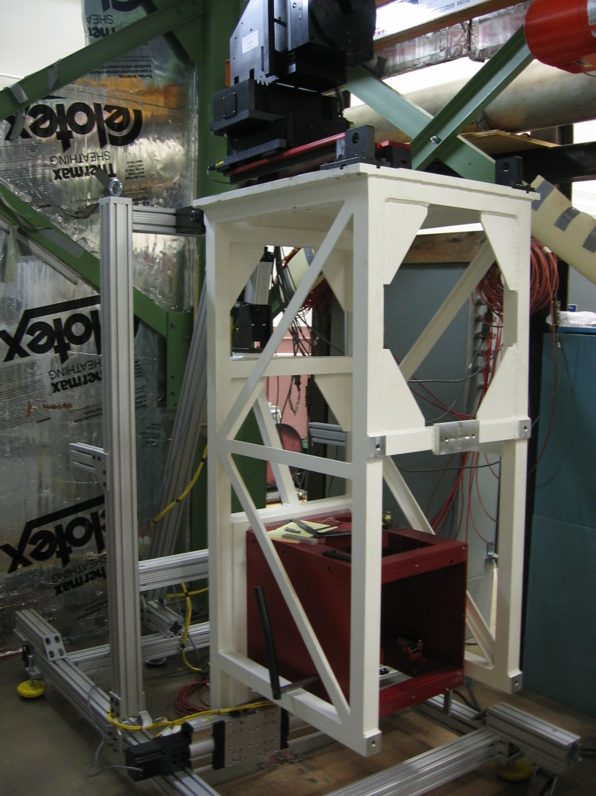
3-axis stage
Tilt stage
CGH positioning stage
B
A

Figure 9: The system. A. Photo of the system, B. Mechanical model of the system.

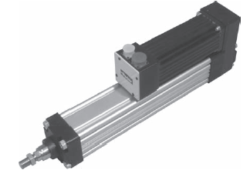
The CGH positioning stage is a 406XR linear slider, the 3-axis stage is 3 400ST series linear stages and the tilt stage is a stepper driven linear piston, all from Parker. The cylinder has not been discussed here, but it has a large travel range (1m or so) but its precision is in the 1mm region. It is also driven by a stepper motor and controlled by the 6k series controller. The electrical box to control this 7-stage system is shown below.
Figure 10: The ET Parker cylinder.
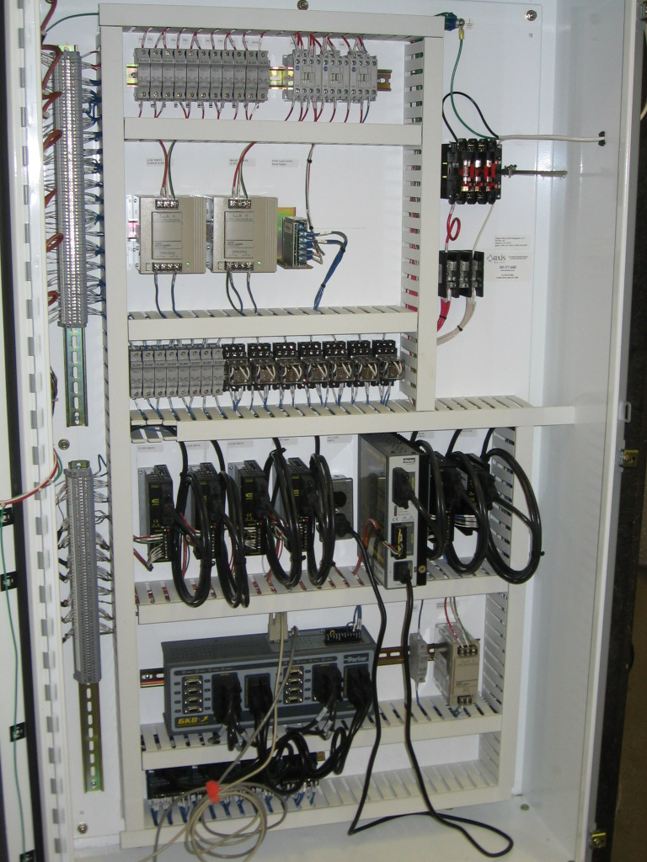
6K8 Controller
Drivers (7)
Computer communication
Input Power Supply
Figure 11: The control system for the null test system.
The power requirements for this system is readily available. The input is 20A, 120V AC power. Care must be taken to have the right fuses, rated for the power amount. The controller has lights to indicate whether the system is working correctly or not.

Conclusions
In conclusion precise motion control is a possibility. A variety of stages, controllers and motors are available from many manufacturers. The requirements must be evaluated so that one is able to match the right stage, motor and controller. It is best to use the 3 components from the same manufacturer but is not a necessity. Computer control can easily be achieved for full automation of such a system. Parker Motion has one of the best options for most applications.

References
1. www.parkermotion.com
2. www.velmex.com
3. www.newmark.com
4. www.aerotech.com
5. Burge, 521 lecture notes, Fall 2006

