Final Design Review
Mounting a Large Lightweight Mirror for Tilting in an Aircraft Application

Mike Borden
OPTI 523

University of Arizona
mborden@optics.arizona.edu

May 15, 2009

Requirement Review:
The following are the design requirements set forth in the design of a mounted, lightweight mirror.
- Optical Requirements
  - 150 nm nominal beam diameter
  - ∆W < 30 nm RMS
  - 90% reflection over 400 nm < λ < 1500 nm range

- Mechanical Requirements
  - Capable of 10° elevation tilt range (45° ± 10°)
  - Resonant frequency > 300 Hz

- System Requirements
  - Temperature range: -50° C < T < 30° C (for aircraft application)
  - Shock loading: 50G

Design Concept:
The design for the mounted, lightweight mirror is shown in Figure 1.
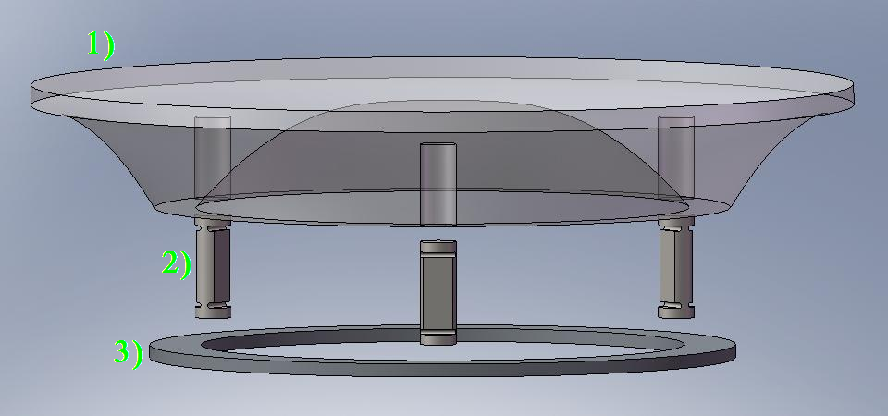
Figure 1: Exploded Assembly View

Component Specifications:
- Lightweight Mirror
  - Double arch design
  - D = 160 mm
  - Max thickness = 24 mm
  - Min thickness = 4 mm
  - Blind Hole Depth = 15.9 mm ± 1 mm
  - Material: Zerodur
  - Coated with protected silver coating
  - Surface Flatness: ETD = 20 Å
  - Surface Roughness: ∆S = 15 Å
  - Mass = 640 g

- Unidirectional Flexure (x3)
  - Height = 20 mm
  - Minimum flexure thickness = 1.5 mm
  - Diameter of flexure head = 7 mm
  - Material: Stainless Steel

- Mounting Ring
  - D = 114 mm
  - Thickness = 2.54 mm
  - Material: Invar

Assembly Procedure:
- Once mirror has been fabricated, ensure that the surface roughness of bottom surface of blind holes is adequate for applying epoxy. This may require additional surface preparations to be ready for epoxy.
- Clean bottom surface of blind holes and top of flexures to remove dust and debris.
- If there is reason to believe that this bond may be removed at a future date, apply a thin layer of silicone on each surface. Otherwise, continue on with Step 4.
- Apply a small amount of epoxy to the inside of the blind hole. The epoxy should have a thickness of .1 mm with a radius of 3.5 mm.
- While being sure to keep flexure with its flat face directed towards the center of the mirror (so that it is oriented radially), attach flexure to the back side of mirror.
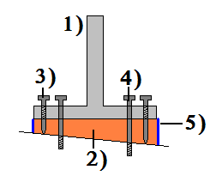
Figure 2: Castable Shim
- Flexure
- Epoxy
- Jacking screw
- Fixing Screw
- Tape Dam

- Clean top surface of the invar ring and the bottom surface of the flexures to remove dust and debris.
- A castable shim is to be used to fix the other side of the flexure to the invar ring. Thus, the tightly toleranced drilled / tapped holes in the flexure need to be lined up with the tightly toleranced drilled / tapped holes in the ring.
- A tape dam is to be made around the outside circumference of flexure.
- The jacking screws are adjusted until a stress free position in flexure is found.
- Pour epoxy into tape dam and let set.
- Once epoxy is set, jacking screws can be removed and the fixing screws should be inserted. This will fix the bottom surface of the flexure to the top surface of the invar ring while maintaining a stress free position.
- Assembly can then be interfaced with whatever mounting structure will be used to hold it at a 45° position.

Component Fabrication / Procurement
- Lightweighted mirror will be a custom made component that will be outsourced to company specializing in lightweight mirrors. Optical coating will need to be applied after completion on mirror and polished to 15 Å surface roughness.
- Flexures will likely be outsourced as well as they will required an EDM to machine to required accuracy.
- Invar ring can be manufactured in-house or by a 3rd party, depending on skill of in-house machinists.

Fulfilling Design Requirements:
 | Requirement | How it was met
Optical | 150 mm nomimal beam diameter | Mirror diameter is 160 mm
 | ∆W < 30 nm RMS | Wavefront error minimized through flexure design and mirror fabrication specs
 | 90% reflection over 400 nm < λ < 1500 nm range | Protected silver coating used
Mechanical | Capable of 10° elevation tilt range (45° ± 10°) | Design of flexures accomodates self weight deflection caused by worst case mirror orientation (40°)
 | Resonant frequency > 300 Hz | Flexure design (height, min thickness, material) keep resonant frequency high
System | Temperature range: -50° C < T < 30° C | Compliance in flexure chosen to minimize thermally induced wavefront error on mirror surface.
 | Shock loading: 50G | Min flexure thickness chosen to accommodate shock loading in buckling and flexure rotational stiffness.

Preliminary System Test Plan:
Once the mirror assembly is interfaced to its mounting structure at 45°, the resulting wavefront error should be tested. This metrology testing will likely be done using an interferometer to determine whether the total RMS wavefront error is less than 30 nm.

Appendix A: Drawings
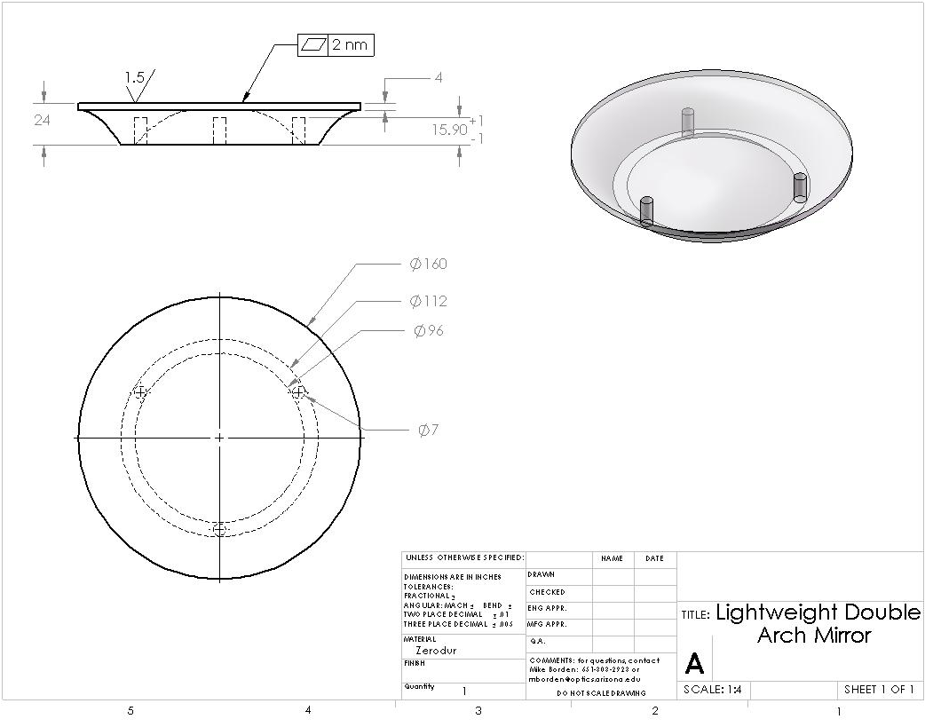
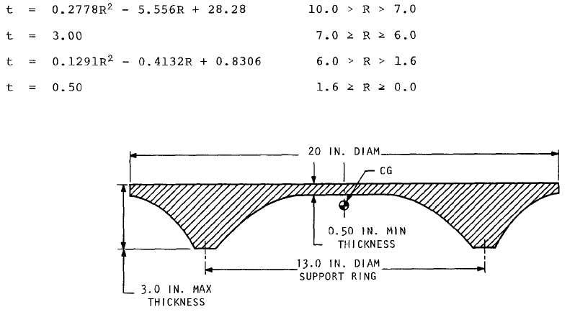

The double arch design was created based off of a scaled down Vukobratovich model from his paper “Optimum Shapes for Lightweighted Mirrors”.

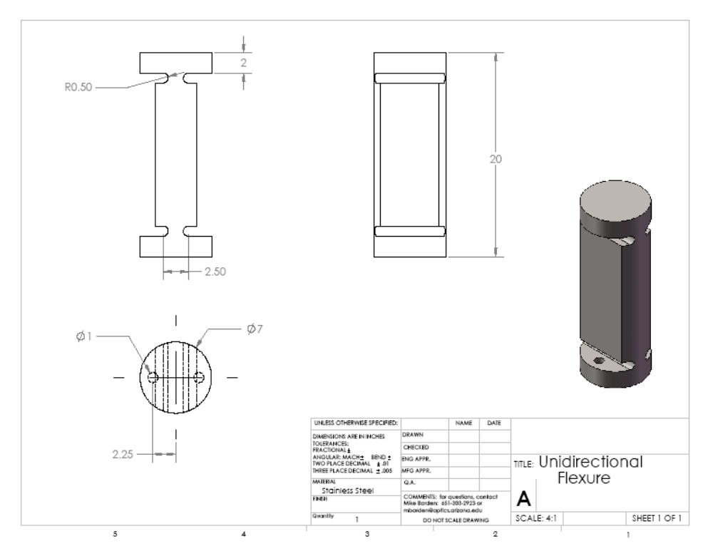
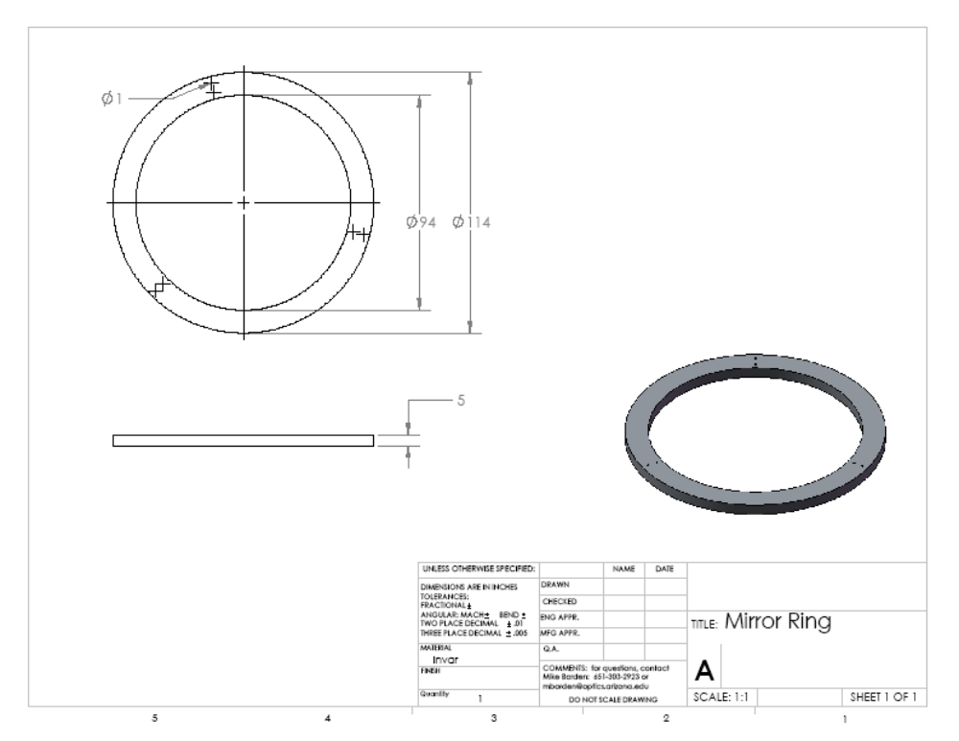
Appendix B: Engineering Trade Studies:
- Type of Lightweight
Selecting the type of lightweight to use for this design was a major consideration early on in the process. The main need to use a lightweighted mirror for this design was to design a system with a resonant frequency that met the design requirements (300 Hz). By using a lighter mirror, this resonant frequency specification would be easy to meet.
There were 5 different types of lightweighted mirrors that were considered. These included: single arch, double arch, open-back, symmetric sandwich, and solid. Based on some of the less desirable properties of the single arch and the solid, they were not chosen for this design. A comparison chart taken from Tina Valente’s technical paper, “A comparison of the merits of open-back, symmetric sandwich, and contoured back mirrors as light-weighted optics” became very useful in making the final decision.
Table 1: Mirror Lightweight Comparison
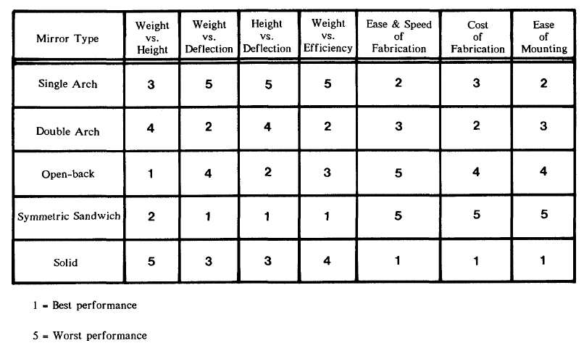
One of the most significant parameters for this trade study was the weight vs. deflection, as this design requires a low weight to keep the resonant frequency high and low deflection to meet the wavefront error specs. Thus the open-back design was the least appealing of the final three types. Eventually the cost of fabrication and the ease and speed of fabrication became the final driving factors in selecting a Double Arch design for this mirror.

- Flexure Dimensioning
Giving the flexure the correct properties ended up being the largest component of the entire design. There were 4 parameters that could be adjusted to help minimize surface deflection in the mirror and increase the system resonant frequency. Those parameters were: minimum thickness of flexure, height of flexure, material, and the depth of blind hole used to adhere flexure to back side of mirror. All of these play some role in meeting the design requirements.
Flexure Material
The flexure material that was chosen was stainless steel. A major trade study was not done to select this material. Rather, stainless steel was found to be a commonly used material for flexure designs. For this reason, stainless steel was chosen for this design.
Flexure Height
In the beginning stages of designing this flexure, 20 mm was chosen as sort of an educated guess. This was the value that was used moving forward and ended up leading to acceptable results. Thus, 20 mm was chosen for the height of this flexure.
Depth of Blind Hole
Adjusting where the flexure will interface with the mirror is an easy way to minimize the amount of surface deflection the mirror will undergo. Ideally, the flexure can be placed right at the mirror’s neutral axis. A study based on the depth of the blind hole used to adhere the flexure to the mirror was done to see what depth would be optimum. The following study was done using a 1.5 mm minimum flexure thickness. The result of where the surface deflection is minimized is shown in Figure 3.
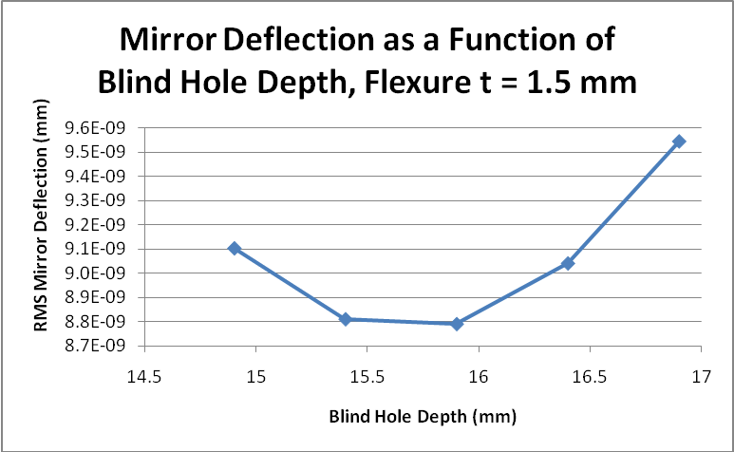
Figure 3: Mirror Deflection as a Function of Blind Hole Depth
It can be seen from Figure 3 that the minimum deflection is found at 15.9 mm. This is the specification that will be given to the mirror manufacturers. Because no machining is perfect, a tolerance must also be placed on this value. Figure 3 also shows how the surface deflection changes as a function of blind hole depth.
It can be seen from Figure 3 that mirror surface deflection is only slightly affected by how accurate the depth of that hole is toleranced to. As a result, I have decided to specify this dimension to 15.9 mm +/- 1 mm.

Flexure Minimum Thickness
Determining the flexure minimum thickness was the most challenging element of this design as varying the thickness caused major performance changes. There were 5 different analyses that were conducted that considered the flexure minimum thickness as the main variable. These were: the Von Mises stress in the flexure due to thermal expansion / contraction, resonant frequency, buckling, rotational stiffness / pivot compliance, and mirror surface deflection.
  - Von Mises Stress Due to Thermal Expansion / Contraction
For these analyses, a CosmosWorks and a theoretical analysis were completed were possible. This was the case for the Von Mises stress study.
The nature of how the mirror assembly is put together and how the flexure is designed is to have compliance in the mirror radial direction. Thus, this compliance will help to minimize the effects of thermal expansion / contraction. As both the CosmosWorks and Theoretical analysis require the amount of thermal expansion, this was calculated first. The thermal expansion was calculated as follows:
Table 2: Thermal Expansion Calculation Values
Zerodur CTE (E-6) [K^-1] = | 2.0E-08
Invar CTE (E-6) [K^-1] = | 6.3E-07
dCTE = | 6.1E-07
R_support (m) = | 0.052
dT (K) = | 80

The value being used for R_support is the distance from the center of the mirror to where the flexure is mounted. This ended up being 52 mm in the final design. Thus:
This value of thermal expansion / contraction was used moving forward.
Thus, for the CosmosWorks portion of this study, the appropriate restraints were used and a force mimicking the deflection that would be caused from thermal expansion / contraction was applied. This modeling is shown in Figures 4 and 5 below.
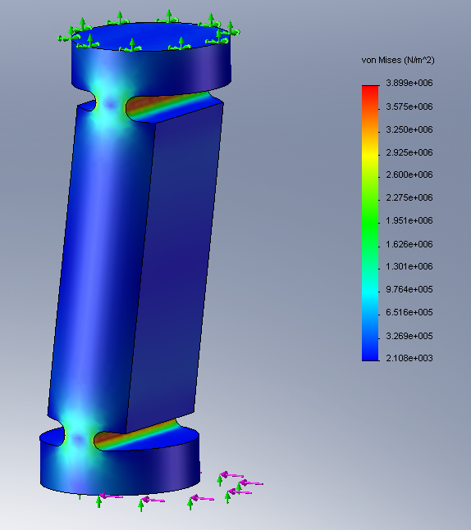
Figure 4: CosmosWorks Flexure Restraints and Applied Forces
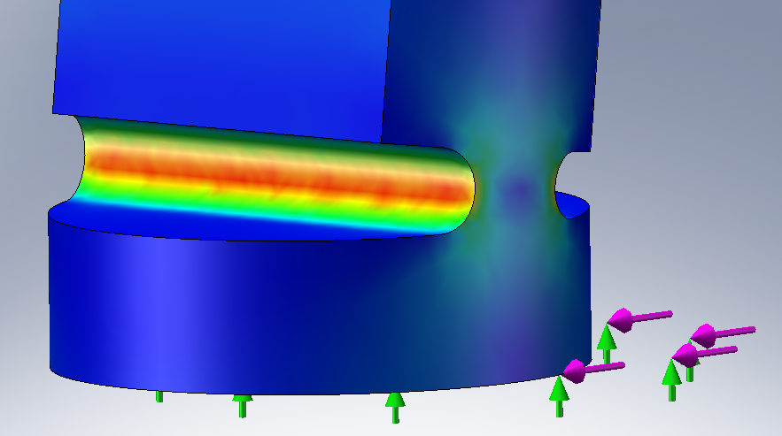
Figure 5: CosmosWorks Flexure Restraints and Applied Forces
To find the force necessary to mimic the displacement caused by thermal expansion, the radial stiffness of the flexure needed to be known. What was then observed was the deflection caused by that 1 N force. The flexure radial stiffness was then calculated using the following relationship:
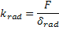
A table showing the deflections caused by the 1 N force as well as the resulting radial stiffnesses is found below:
Table 3: CosmosWorks Deflection and Stiffness Results
 |  | H - Rad (mm)
 |  | 0.5 | 1 | 1.5 | 2 | 2.5
Deflection (mm) |  | 5.55E-06 | 1.18E-06 | 4.90E-07 | 2.67E-07 | 1.69E-07
Stiffness (N/m) |  | 1.80E+05 | 8.50E+05 | 2.04E+06 | 3.74E+06 | 5.93E+06

Now that the stiffness is known for flexure thicknesses between .5 mm and 2.5 mm, the resulting forces being caused in the radial direction can be calculated. These forces are a result of the fact that the flexures are not perfectly compliant. At the same time, this is the same force used to mimic the necessary deflection caused from thermal expansion. This force was calculated as follows:
These resulting forces were then applied to the model in CosmosWorks and the resulting Von Mises stresses were observed. Factors of Safety using these observed Von Mises stresses were also calculated using the yield strength of stainless steel, which is 300 MPa. These results are showing in Table 4.
Table 4: CosmosWorks Force and Von Mises Stress Results
 |  | H - Rad (mm)
 |  | 0.5 | 1 | 1.5 | 2 | 2.5
Force (N) |  | 0.46 | 2.16 | 5.18 | 9.50 | 15.04
Shear Stress (N/m^2) |  | 1.23E+07 | 1.69E+07 | 2.02E+07 | 2.40E+07 | 2.57E+07
Shear Stress FS |  | 24.41 | 17.71 | 14.85 | 12.49 | 11.66

Next, the theoretical Von Mises stresses were calculated. First the theoretical flexure radial stiffness was calculated. This was done using the equation:
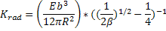
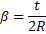
Where R is the radius of curvature at the flexure pivots, t is the thickness of that pivot, E is Young’s Modulus for stainless steel, and b is the depth of the flexure pivot. Using this flexure radial stiffness, the resulting forces were calculated in the same way as was done for the CosmosWorks analysis.
One of the challenges of the theoretical analysis was calculating the correct Von Mises stress. Due to the unusual geometry of the flexure and a lack of time, I ended up scaling the theoretical Von Mises stress from the CosmosWorks Von Mises stress. This was done using the following equation:
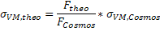
The assumption that I made in using this calculation is that Von Mises Stress scales linearly. Using this calculated stress, Factors of Safety were also calculated. The results from the Theoretical analysis can be found in Table 5.
Table 5: Theoretical Analysis Results
 |  | H - Rad (mm)
 |  | 0.5 | 1 | 1.5 | 2 | 2.5
K - DeflZ ForceZ (N/m) |  | 3.07E+05 | 2.46E+06 | 8.30E+06 | 1.97E+07 | 3.84E+07
Force (N) |  | 0.78 | 6.24 | 21.05 | 49.90 | 97.46
Shear Stress (N/m^2) |  | 2.10E+07 | 4.90E+07 | 8.21E+07 | 1.26E+08 | 1.67E+08
Shear Stress FS |  | 14.30 | 6.12 | 3.65 | 2.38 | 1.80

Figures 6 and 7 show how the CosmosWorks and Theoretical analyses compare.
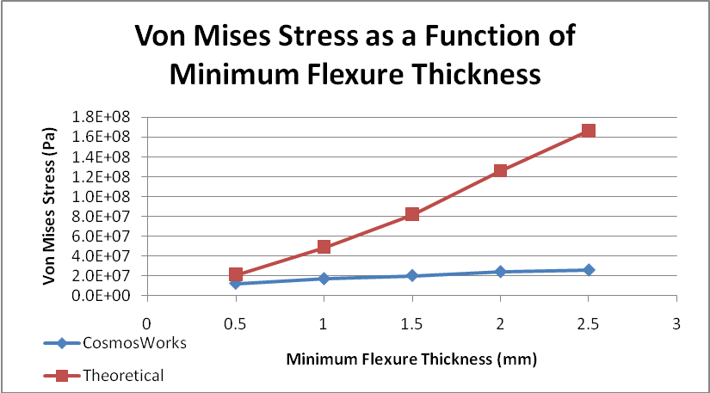
Figure 6: Von Mises Stress CosmosWorks / Theoretical Comparison
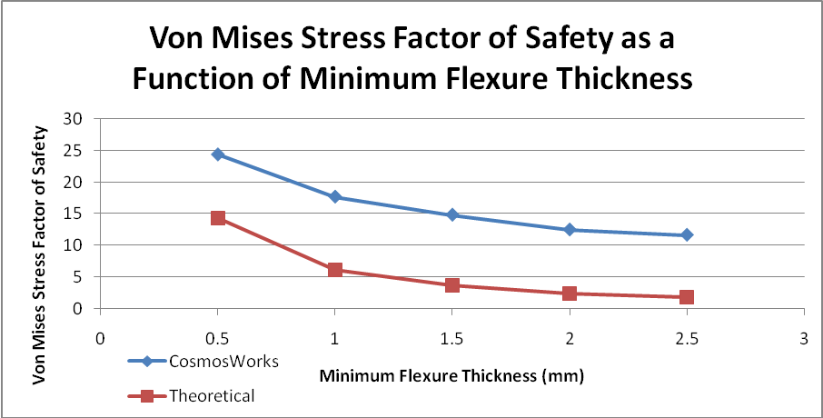
Figure 7: Von Mises Stress Factor of Safety CosmosWorks / Theoretical Comparison
It can be immediately seen that there is a discrepancy between the theoretical stresses and the stresses seen in CosmosWorks. For the theoretical analysis, I tried a number of different flexure radial stiffness equations and the result did not improve. My best guess is that my scaling assumption was incorrect. Again due to time constraints, this analysis will move forward with these results.
Assuming that the theoretical values are true, they result in the smaller factors of safety. To be conservative in this design, I have moved forward using the theoretical values as my limiting factor for Von Mises stress in the flexure. The following Table became useful in drawing conclusions about flexure thickness.
Table 6: Von Mises Stress Factor of Safety Comparison
Shear Stress FS | H - Rad (mm)
 | 0.5 | 1 | 1.5 | 2 | 2.5
CosmosWorks | 24.4 | 17.7 | 14.9 | 12.5 | 11.7
Theoretical | 14.3 | 6.1 | 3.7 | 2.4 | 1.8

Conclusion:
The two factors of safety that are worrisome in this analysis are for 2 mm and 2.5 mm flexure minimum thicknesses. Thus, they have been removed from the list of possible flexure thicknesses moving forward.

  - Resonant Frequency
The resonant frequency was calculated only theoretically for this part of the analysis. The reason a CosmosWorks resonant frequency analysis was not accomplished was because of computer and software troubles trying to run this analysis. I was able to get a few basic resonant frequency tests done but the wait time to run the analysis was limiting (25+ minutes per run). When I went to use some of the high end computers in “the Zone” on campus, SolidWorks would crash every time the test was run. This is unfortunate, but the theoretical analysis that was completed gave me confidence that the resonant frequency would not be a concern in this design.
There were 4 different directions of resonant frequency calculated. These are shown in Figure 8.
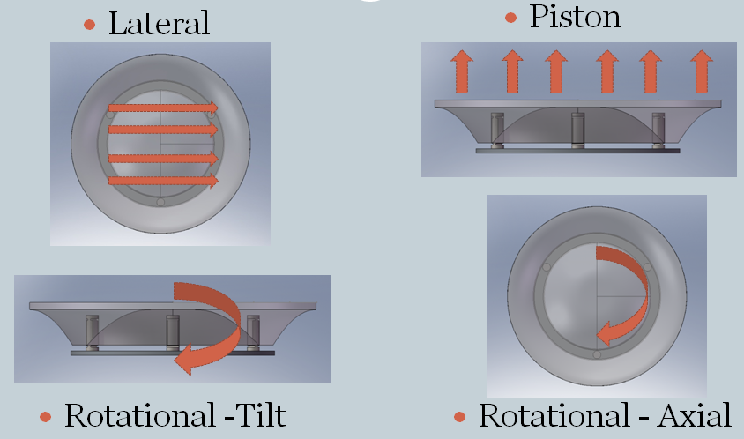
Figure 8: Resonant Frequencies Calculated
In each case, the resonant frequency was calculated by applying either a force of 1 N or a moment of 1 Nm to the assembly in the appropriate direction / location. The resulting displacement was then observed and the stiffness in that direction was calculated. Finally, the resonant frequency was calculated using the equation:
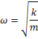
where m is the mass of the mirror. The results are shown in Table 7.

Table 7: Resonant Frequency Results
Res Freq (Hz) | H - Rad (mm)
 | 0.5 | 1 | 1.5 | 2 | 2.5
Lateral | 3.74E+03 | 4.34E+03 | 4.87E+03 | 5.35E+03 | 5.79E+03
Piston | 1.55E+04 | 1.67E+04 | 1.74E+04 | 1.80E+04 | 1.85E+04
Rotational - Tilt | 4.60E+03 | 4.85E+03 | 5.02E+03 | 5.14E+03 | 5.24E+03
Rotational - Axial | 2.62E+03 | 2.97E+03 | 3.22E+03 | 3.41E+03 | 3.56E+03

By using the required resonant frequency for this design, 300 Hz, factors of safety for each kind of resonant frequency was determined.
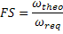
This is shown in Table 8 and Figure 9.
Table 8: Resonant Frequency Factors of Safety Results
FS Res Freq | H - Rad (mm)
 | 0.5 | 1 | 1.5 | 2 | 2.5
Lateral | 12.5 | 14.5 | 16.2 | 17.8 | 19.3
Piston | 51.8 | 55.6 | 58.2 | 60.1 | 61.5
Rotational - Tilt | 15.3 | 16.2 | 16.7 | 17.1 | 17.5
Rotational - Axial | 8.7 | 9.9 | 10.7 | 11.4 | 11.9

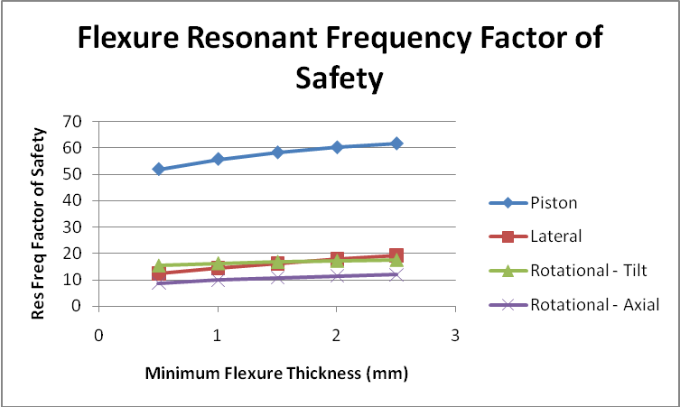
Figure 9: Resonant Frequency Factors of Safety
It can be seen from both Table 8 and Figure 9 that the theoretical factors of safety are adequate for this design. The worst type of resonant frequency is the Rotational – Axial and even the thinnest flexure had a factor of safety of 8.7. This gives me confidence that every flexure thickness will adequately meet the resonant frequency design requirement of 300 Hz.
Conclusion:
No minimum flexure thickness can be eliminated as a result of resonant frequency.

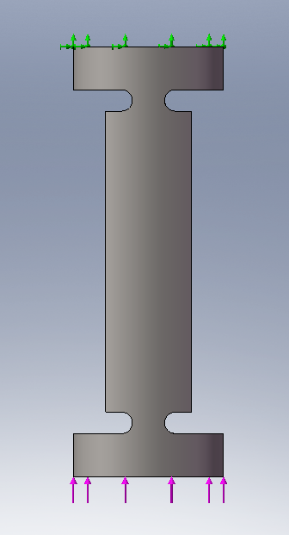
  - Buckling
A buckling analysis was completed in CosmosWorks. This was done by applying a vertical load to the flexure equal to 1/3 the mass of the mirror. The 50G shock loading was also applied. This is seen in Figure 10.
The results of this are shown in Table 9 and Figure 11.

Figure 10: Flexure Buckling Loading

Table 9: CosmosWorks Flexure Buckling Results
 |  | H - Rad (mm)
 |  | 0.5 | 1 | 1.5 | 2 | 2.5
Buckling Stress (N/m^2) |  | 5.01E+07 | 3.17E+07 | 2.65E+07 | 2.36E+07 | 2.09E+07
FS Buckling Stress |  | 6.0 | 9.5 | 11.3 | 12.7 | 14.3

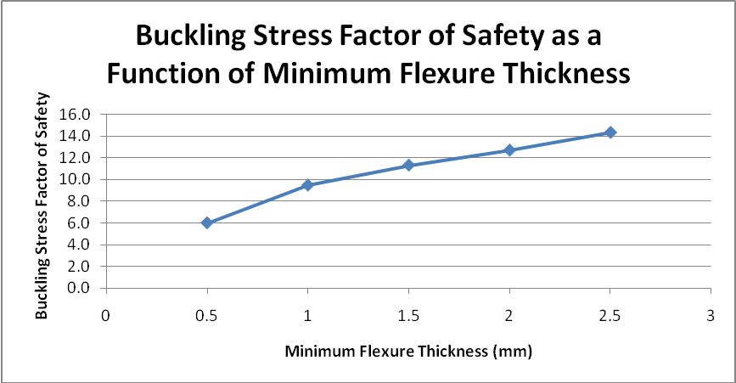
Figure 11: CosmosWorks Flexure Buckling Results
It can be seen from Table 9 and Figure 11 that buckling is not of major concern in this design. Even with the 50G shock loading, the weight of the mirror is simply not great enough to cause any serious problem. Thus, all flexure thickness will be adequate.
Conclusion:
No minimum flexure thickness can be eliminated as a result of buckling.

  - Rotational Stiffness / Pivot Compliance
The rotational stiffness was calculated using CosmosWorks. As thermal expansion occurs and the top surface of the flexure is displaced, the applied force then becomes a moment. This can be seen in Figure 12.
In order for the flexure to remain stable, it must produce an equal and opposite resisting moment. This resisting moment must be greater than the moment applied during thermal expansion.

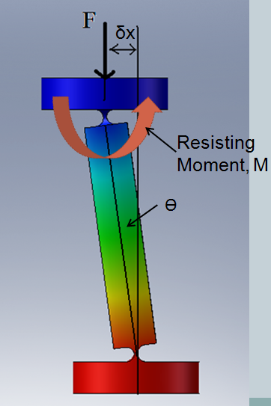
Figure 12: Resultant Moment in Flexure due to Thermal Expansion
In order to calculate the moment caused by thermal expansion, the following equation was used:
Through geometry, it is known the angle which is created as a result of thermal expansion. Thus, rotational stiffness can be calculated using the equation:
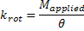
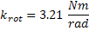
The required resisting moment is thus created by the non-perfect compliance in the flexure pivot. To calculate the resisting moment, a 1 Nm moment was applied to the flexure in CosmosWorks and the resulting rotational displacement was observed. Again, through geometry, the resulting angle was calculated and the resisting rotational stiffness was calculated. This stiffness was then compared to the minimum rotational stiffness required to calculate a factor of safety.
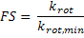
Table 10 and Figure 13 show the results of this study.
Table 10: Rotational Stiffness CosmosWorks Results
 |  | H - Rad (mm)
 |  | 0.5 | 1 | 1.5 | 2 | 2.5
Rotational Stiffness (Nm/rad) |  | 3.25 | 14.53 | 33.37 | 59.36 | 92.30
FS Rotational Stiffness |  | 1.01 | 4.52 | 10.39 | 18.48 | 28.73

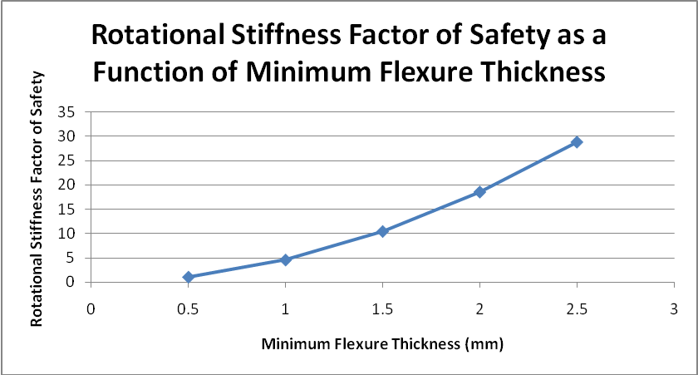
Figure 13: Rotational Stiffness Factor of Safety CosmosWorks Results
It can be seen from both Table 10 and Figure 13 that in some cases the rotational stiffness factor of safety is simply too small. This was the case for a minimum flexure thickness of .5 mm.
Conclusion:
Minimum flexure thickness of .5 mm has been eliminated from feasible flexure thicknesses.

  - Mirror Surface Deflection
The mirror surface deflection is affected by the blind hole depth, which was already discussed, as well as the minimum thickness of the flexure. Again, because the flexure is not perfectly compliant, it will be applying a force at the interface of the flexure and mirror. This force is at a maximum when the thermal deflection is at a maximum. Thus, the force that was calculated during the thermal expansion stress analysis is the same force that will be applied to the mirror. Table 11 and Figure 14 show those forces.

Table 11: Forces Applied to Mirror from Flexures
Force (N) | H - Rad (mm)
 | 0.5 | 1 | 1.5 | 2 | 2.5
CosmosWorks | 0.46 | 2.16 | 5.18 | 9.50 | 15.04
Theoretical | 0.78 | 6.24 | 21.05 | 49.90 | 97.46

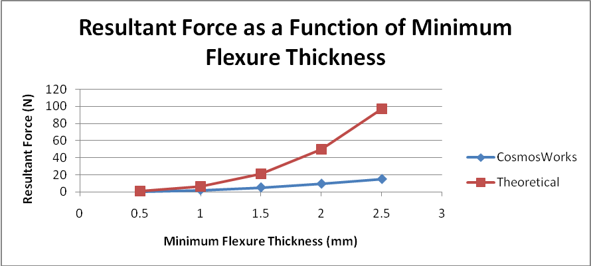
Figure 14: Forces Applied to Mirror from Flexures
Again, to be conservative, the theoretical values were used in this analysis. When these values were applied at a blind hole depth of 15.9 mm +/- 1 mm, the resulting mirror surface deflections are observed and shown in Table 12. It should also be noted that self weight deflection is also being considered in this same analysis due to the nature of how the mirror was modeled in SolidWorks.
Table 12: Mirror Deflection Results
 | Mirror Deflection (m) - rms from CosmosWorks |  | H - Rad (mm)
Blind Hole Depth (mm) |  |  | 0.5 | 1 | 1.5 | 2 | 2.5
Blind Hole Depth (mm) | 14.9 |  | 4.78E-09 | 5.19E-09 | 9.10E-09 | 1.95E-08 | 3.76E-08
Blind Hole Depth (mm) | 15.9 |  | 4.78E-09 | 5.10E-09 | 8.79E-09 | 1.89E-08 | 3.65E-08
Blind Hole Depth (mm) | 16.9 |  | 4.84E-09 | 5.23E-09 | 9.54E-09 | 2.10E-08 | 4.07E-08

These RMS deflections were found by exporting deflection data from CosmosWorks into Matlab and running Won Hyun’s surface slope .m file. An example of the resulting mirror surface deflection is shown in Figure 15, where the minimum flexure thickness is 1.5 mm at a blind hole depth of 15.9 mm.
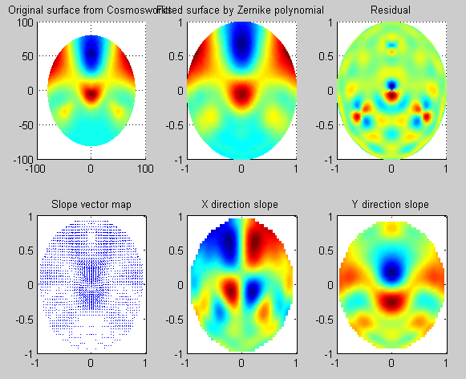
Figure 15: RMS Deflection resulting from Slope Matlab program
Figure 16 shows how the mirror surface deflection changes with varying blind hole depths and minimum flexure thicknesses.
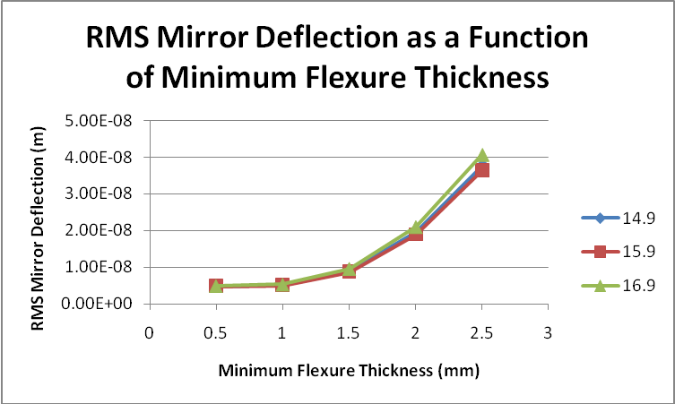
Figure 16: RMS Mirror Surface Deflection
The 30 nm RMS wavefront error needs to be kept in mind here. The mirror surface deflection will be only one part of the total wavefront error calculation. Thus, it needs to remain substantially less than this 30 nm RMS wavefront error. By looking at Figure 16, it becomes clear that the 2 and 2.5 mm minimum flexure thicknesses will be applying too large a force to the mirror causing too great a wavefront error.
Conclusion:
Although 2 and 2.5 mm minimum thickness flexures have already been removed from consideration, the RMS wavefront deflection requirement also eliminates these from being chosen for this trade study.
  - FINAL CONLCUSIONS FROM MINIMUM FLEXURE THICKNESS TRADE STUDY
The only remaining flexure thicknesses that have been analyzed are 1 mm and 1.5 mm. Table 13 shows the entire comparison between the 2.
Table 13: Comparison Between 1 mm and 1.5 mm Minimum Flexure Thicknesses
 |  | Flexure Thickness (mm)
 |  | 1 | 1.5
Von Mises Stress FS | CosmosWorks | 17.7 | 14.9
 | Theoretical | 6.1 | 3.7
Lateral Res Freq FS | Theoretical | 14.5 | 16.2
Piston Res Freq FS | Theoretical | 55.6 | 58.2
Rotational - Tilt Res Freq FS | Theoretical | 16.2 | 16.7
Rotational - Axial Res Freq FS | Theoretical | 9.9 | 10.7
Buckling Stress FS | CosmosWorks | 9.5 | 11.3
Rotational Stiffness FS | CosmosWorks | 4.5 | 10.4
Mirror Deflection RMS | CosmosWorks | 5.10E-09 | 8.79E-09

It is clear that both fulfill adequate factors of safety for each parametric study. However, the boxes that are highlighted in green are the factors of safety that will help to make a final decision. Because of the very good factor of safety of 10.4 for rotational stiffness and acceptable factor of safety of 3.7 for Von Mises stress, the 1.5 mm minimum flexure thickness will be used.
1.5 mm minimum flexure thickness will be used
Appendix C: Detailed Analysis:
- Optical Coating
The coating being used is protected silver from Majestic Optical Coatings.
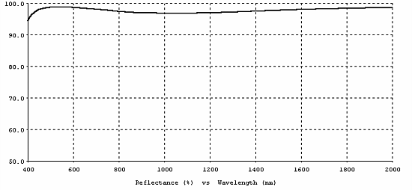
Figure 16: Reflectivity Curve of Protected Silver
The above reflective coating offers an average reflectivity of 97% from 500nm to 750nm and 98%
from 800nm to out passed 10 microns.
Specs for this coating can be found at: http://www.majestic-coatings.com/coating-p-silver.html

- Wavefront Error
There are 4 different factors being considered into the total wavefront error calculation. The first is the mirror deflection being caused by self weight deflection and forces from the flexures. The remaining factors are window flatness, surface roughness, and figure irregularity. The specifications made for each parameter are shown in Table 14.
Table 14: Wavefront Error Parameters
 | Parameters | delta_W RMS (nm)
Surface Roughness | delta_S = 1.5 nm | 0.75
Surface Deflection | 15.9 mm hole depth | 17.58
 | 16.9 mm hole depth | 19.08
Surface Flatness | ETD = 2 nm | 6.25
Figure Irregularity | 10 nm RMS | 10

Because this design should accommodate the worst possible scenario, the surface deflection value at 16.9 mm blind hole depth will be used to calculate the total RMS Wavefront error.
Conclusion:
The total wavefront error for a large lightweight mirror assembly with a 1.5 mm min thickness flexure at a blind hole depth of 16.9 mm is thus 22.44 nm RMS. This successfully meets the requirement of <30 nm RMS WFE.
- Stress in Adhesive:
The epoxy being used will undergo shear stress as thermal expansion occurs. Thus, the size of the epoxy used must create an acceptable amount of stress. The shear stress found in the epoxy is calculated using the following equation from Vukobratovich’s Introduction to Opto-Mechanical Design book.
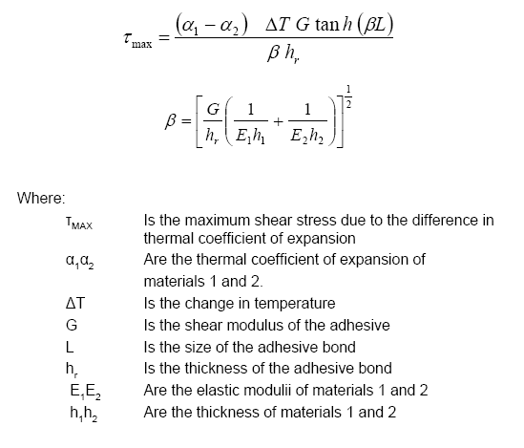
Using these equations and the correctly properties of epoxy, the appropriate dimensions for the epoxy spot were made. The size of the adhesive bond, L, has been determined to be 3.5 mm in radius. As the flexure itself is 3.5 mm in radius, the entire top face of the flexure can be coated with epoxy. Using a 0.1 mm thick bond, the resulting shear stress is found to be 1.57 MPa, which, using the allowable stress in epoxy, has a factor of safety 8.91.
Lessons Learned:
This was an incredibly useful study for me. As was mentioned in class, when mounting optics with flexures, the flexure design ends up being the most significant element of the design. It was great experience to be able to go through the process of flexure design. The most valuable element of that process was the parametric study. The geometry of the flexure was hugely important in fulfilling the requirements placed upon the system. Being able to see the effect of changing that geometry was useful as an engineer.
One of the major things I learned was about defining my requirements. I struggled early in the project to adequately define what I was looking to do. This left me treading water a bit when trying to attack the design. Once the requirements were well established, then it became much easier to make progress in the analysis.
One of the areas I failed at in this design was using an error budget. This had been mentioned during my FDR. I went through my analysis and found out what kind of WFE’s I was going to be getting through the mirror surface deflection, and then let the rest of the contributors to WFE fill in the blanks afterwards. I understand that this is bad practice, so it was good for me to get firsthand experience making that mistake. The goal next time around is not to make the same mistake twice.
I also learned about how much work goes into something as seemingly simple as a flexure. The required analysis is really extensive in a design like this, and as I’m quickly discovering, with nearly all opto-mechanical designs.

