Houssine Makhlouf October 31, 2008

Opti 521 – Fall 2008

Introductory to opto-mechanical engineering

**Synopsis of Technical Report**

1. **Paper key results**

*P.R. Yoder Jr.”Lens mounting techniques”, Proc of SPIE Vol. 0389, Optical Systems Engineering III [1983].*

This paper deals with the issue of mounting lenses and is presented in three main parts. First, it lists a few different techniques to mount individual lenses in their metallic cells in a secured way. Then, a detailed analysis of the stress that can occur in a mounted lens is provided and compared to acceptable tolerance values. Finally, the author discusses examples of more complex opto-mechanical systems for which the enunciated techniques are applied.

1. **Techniques to mount individual lenses**

Lens burnishing is an inexpensive technique that allows holding a lens firmly in its mount. A malleable material, such as brass and aluminum alloy, is used for the cell mount. The technique consists of inserting the lens in the mount and pressing a hardened tool against the cell lip in order to bend it such that it retains the lens (Figure 1).

One can also retain a lens by inserting a snap ring that fits into a groove located in the inside surface of the mount. The snap ring can have a circular or rectangular cross section. The ring is difficult to be removed without damaging the lens, so this assembly technique is quite permanent (Figure 2).

A third method consists of leaving some radial spacing between the lens and the cell, and fill in the annular void with resilient material such as an elastomer. The lens is held axially against its mount seat while the material is injected and cured (Figure 3).

A last technique consists of using a threaded retaining ring to secure the lens against a shoulder in a cell. This has the advantage to hold the lens firmly in place, while being repeatable (the lens can easily be assembled and disassembled) and used to mount several elements in the same housing (Figure 4).



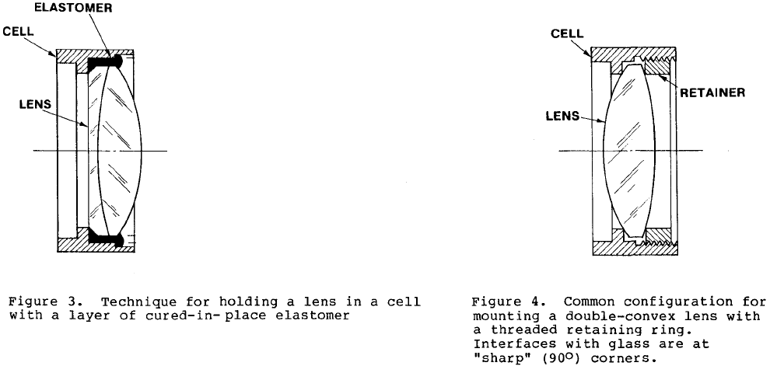

The retaining ring and the annular seat, against which the lens is pressed, can be cut square (most common and easiest to machine), tangent to the lens surface or spherical with the same radius of curvature as the lens surface. The tangent case can cause a misalignment of the lens axially if it is not shaped accurately enough. The spherical case is hard to make precisely and expensive.

To help minimize nicks and burrs, the square seat and retainer can be beveled at 45° such that the corner in contact with the lens is obtuse.

Configurations for the three cases described above are shown in Figure 5.



In the case of concave surfaces, flat bevels are used but these need to be perfectly perpendicular to the optical axis in order to be able to center both surfaces of a lens simultaneously on a common mechanical axis. This issue can be bypassed by using obtuse contact (Figure 6). Also tangent interfaces cannot be used with concave surfaces.



1. **Analysis of stress in glass-metal interface**

It is important to hold a lens tightly in its metallic mount since it might be intended for use in a severe shock or vibration environment, and the lens must stay well aligned. However this is a source of stress onto the glass. One can classify stress in two categories: axial stress and radial stress.

The contact between the lens glass and the seat, spacer or retaining ring causes an axial compressive stress that is defined as a preload at the normal operating temperature. This preload depends upon the type of cut for the seat and upon temperature.

The line contact between a square-corner seat and the lens is equivalent to the line contact of two parallel cylinders of different diameters and uniformly loaded against each other. The axial compressive stress for preload and the axial stress due to temperature change and the can be computed theoretically with the appropriate equations reported in the paper. The net axial stress is simply the sum of the two contributions.

It is also shown that the preload can be dramatically reduced by using a design with tangential contact between glass and mount instead of a square cut. This is equivalent to the contact between a cylinder and a flat surface.

A second kind of stress is denominated radial stress and is caused by extreme temperature decreases as the cell exerts a large radial compression onto the glass, which may result in a lens break down. Again the paper gives a theoretical formula that allows calculating the value of this stress.

The kind of parameters that are involved in the equations mentioned above, are lens and mount diameters and radii of curvature, Young’s modulus, Poisson ratio, coefficient of thermal expansion, temperature variation. The author uses all these equations to compute stress values for a typical lens-mount system and illustrate his point. It turns out that under standard operating conditions, the calculated net stress does not reach the level that a typical glass such as BK7 can withstand (over 50 ksi).

Also stress itself can cause birefringence and surface deformation. The author does not give details about surface deformation, but shows that birefringence can be negligible for standard stress values.

Nevertheless it is important to be able to predict the stress onto the glass of an opto-mechanical system as some specific applications require extreme operating conditions (e.g. wide range of temperature).

1. **Application: examples of real systems**

In this last part, the author discusses examples of opto-mechanical systems to illustrate use of the lens mounting techniques described earlier in the paper.

The author shows the design for two systems intended for military use. Features relevant to the previous discussion only are highlighted. The reader is invited to refer to the original paper for details about the designs.

The first one is a fixed focus telescope eyepiece which is stack-mounted, that is the lenses are inserted sequentially into the cell. The spacers and final single threaded retainer are square shaped. The design is intended to be effective for common military environment. It needs to operate under a wide range of temperatures (-80ºF to +160ºF) and pressure differentials of at least ±5psi (Figure 13).

The second system design consists of a multiple-element high-performance telescope objective again for military use. It is made to withstand harsh shock and vibration environment. It uses a square retainer as well. The radial compression stress is evaluated to be much lower than the acceptable limit corresponding to the glass failure (Figure 14).



The author ends up his discussion by presenting another assembly technique that he calls lathe assembly technique. It consists of positioning elements radially by the inside diameter of the housing. This technique is illustrated through specific examples that the reader should check out for details about the methods, materials and tools.

1. **Comments on paper**

At first sight, we may assume the information reported in this paper is useful to every opto-mechanical engineer and designer since all optical systems obviously involve lens mounting. However the author shows that special care on the mechanical design in terms of spacing, ring retainer material and size and so on, is mostly required for specific applications involving severe environment issues. It turns out that preload and thermal stress occurring as the metallic mount pushes against the glass to hold a lens in a proper position, remain far below the limit of glass failure.

Consequently, we can conclude that the results in this paper should ensure optical scientists who build systems for use in a laboratory-type environment (research lab, hospital…), that their systems would perform well. But special care for the design should be taken for those scientists who must deal with extreme environment conditions such as large temperature variations and special pressure constraints. This mostly corresponds to an outdoor environment and can be applied to military devices (binoculars, telescopes), nature capturing systems (camera objectives), and astronomical systems (telescopes) to give a few examples.

This paper emphasizes the way of holding a lens tightly in its housing and the influence of stress on this initial position as well as the possibility of glass failure. Another important feature for lens mounting, which is not specifically mentioned in the paper, corresponds to lens centration. A lens needs to be mounted such that its inherent wedge (due to manufacture limits) is compensated by the way it is assembled in order to achieve the desired performance. This is done by aligning the optical axis (defined by the optical surfaces) with the mechanical axis (defined by the housing).

The paper “Some Thoughts on Lens Mounting” by Robert E. Hopkins, addresses this issue in a simple and efficient way. Instead of considering the inner housing diameter as the references axis for alignment, a laser collimator is used in conjunction with the lenses themselves to indicate the straightness of the optical axis. The laser is first aligned perpendicular to a reference plate by observing the returning signal. A first spacer is then placed and centered on the stage of the reference plate. Afterwards a first lens is placed on the spacer and moved around until the optical axis and the collimator are parallel. This is done by superimposing the center of the interference fringes (Newton’s rings) produced by the wavefronts reflected off the three different surfaces (one for the reference plate and two for the lens). Concentric interference patterns correspond to a common axis for the three surfaces. The lens is then cemented. The next spacer is placed and moved about until reflections from the third surface line up with those from the previously aligned surfaces. The operation is repeated depending on the number of elements needed in the housing. At the end the top and bottom spacers are clamped together.

This assembly method exhibits a powerful feature in that the stability and centering of the system is built into the spacers and the lenses. There is no need of precision on all the dimensions of the parts.

**References**

* P.R. Yoder Jr.”Lens mounting techniques”, Proc of SPIE Vol. 0389, Optical Systems Engineering III [1983].
* [R. E. Hopkins “Some Thoughts on Lens Mounting” Optical Engineering 15(5)[1976]](http://www.optics.arizona.edu/optomech/references/papers/Hopkins%201976.pdf)